**CheckMate V2**

**YOU HAVE TO USE NODE.JS   
14.7.5**

**Tony Baker Project**  
  
**Tip: Starting development  
Tip**: Fixing the issue when you fetch for record to edit and then type in a field and all of you data disappears from other fields  
**Tip**: Check for open port  
**Tip**: MongoDB Commands – Visual Studio Code  
**Tip**: Creating custom routes with express js  
**Tip**: How to grab fields from MongoDB and dynamically populate a select  
**Tip**: Splitting the Service and deploying to GCP  
**Tip**: Running the app on a mac (when apache is running and webpack is an issue)  
**Tip**: Deploying to Heroku (SEE THE NOTES ON CHECKMATE V2 – FINALLY GOT IT TO WORK)  
**Tip**: Removing options from a select control  
**Tip**: Comparing both versions of CheckMate  
**Tip**: Fixing this error: - options.allowedHosts[0] should be a non-empty string. – See Notes in V2  
**Tip**: Fixing Macbook deploy issues. – See Notes in V2  
**Tip**: Enabling Authorization – JWT and REDUX – hiding the navigation based on REDUX  
**Tip**: Fixing the issue with warning messages from reactbootstrap next table  
**Tip**: Fixing this error: - options.allowedHosts[0] should be a non-empty string.  
**Tip**: Fixing Macbook deploy issues  
**Tip**: Comparing both versions of CheckMate  
**Tip**: Running VSCode from command in terminal on mac m1  
**Tip**: Using Google Meet for meetings  
**Tip**: Getting the solution run in a docker container  
**Tip**: Deploying to Heroku (Got it to work)  
**Tip**: Splitting out the webservice to Heroku  
**Tip**: Adding styles to the login screen  
**Tip**: Using Controlled components  
**Tip**: Debugging using Chrome DevTools (Without requiring webpack.config file)  
**Tip**: BootStrapReact imports for CSV (the correct ones to use to keep from getting errors with table-next)  
**Tip**: Pulling the image to Docker Public Registry

**Tip**: Pulling the image to Docker Public Registry  
To pull the image:  
docker pull lionel5116/checkmateappv2:0.1

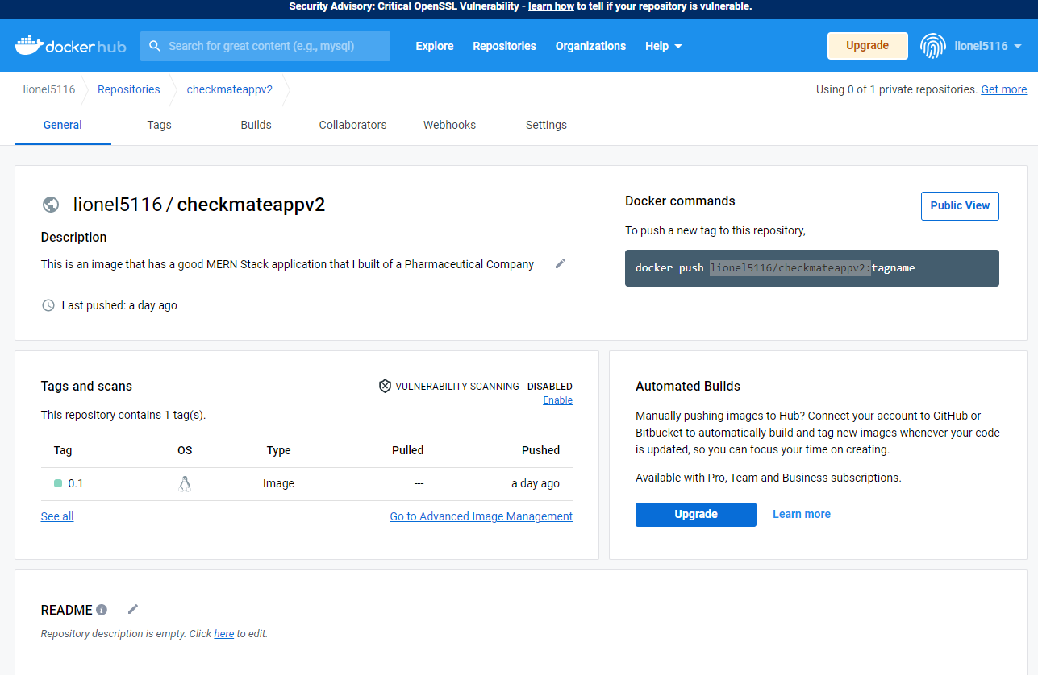  
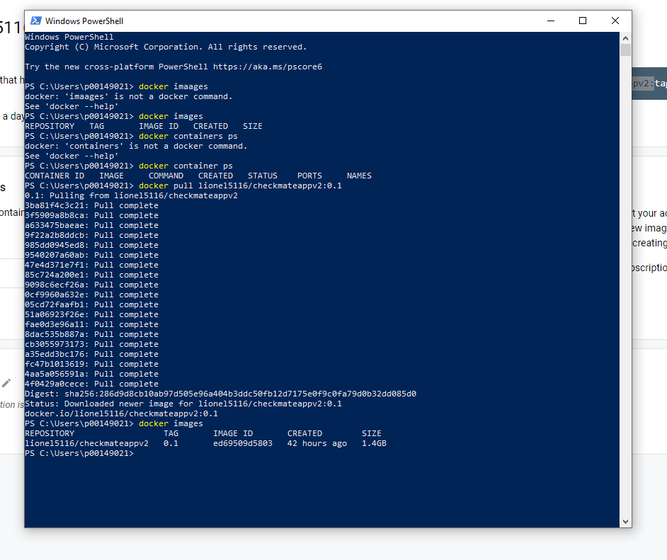

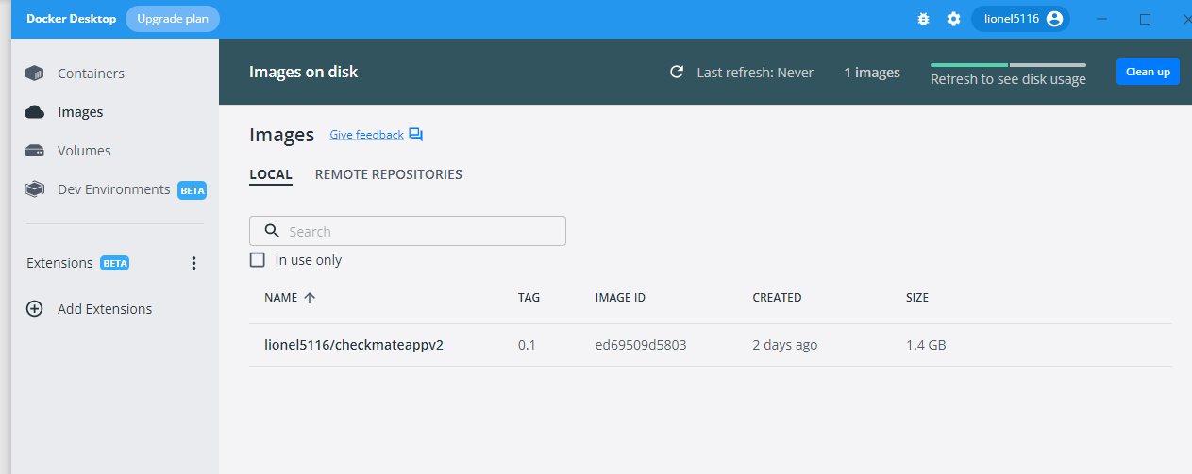 **Now all we have to do is run the image**

docker run --name checkmateappv2-container -p 3000:3000 -p 5500:5500 -d lionel5116/checkmateappv2:**0.1**

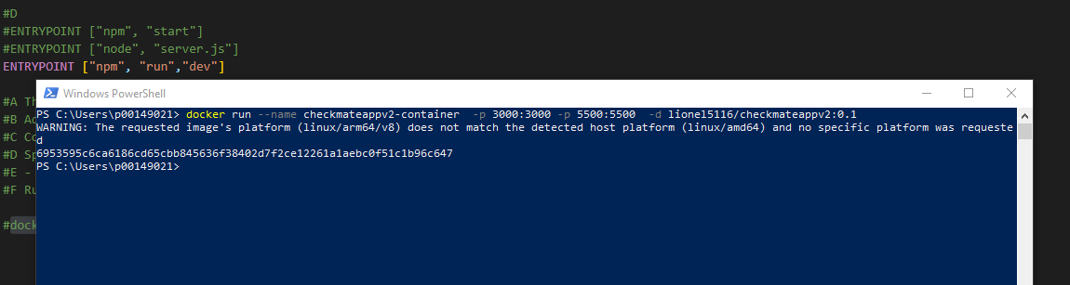 **Notice how we had to add the tag name (in red)**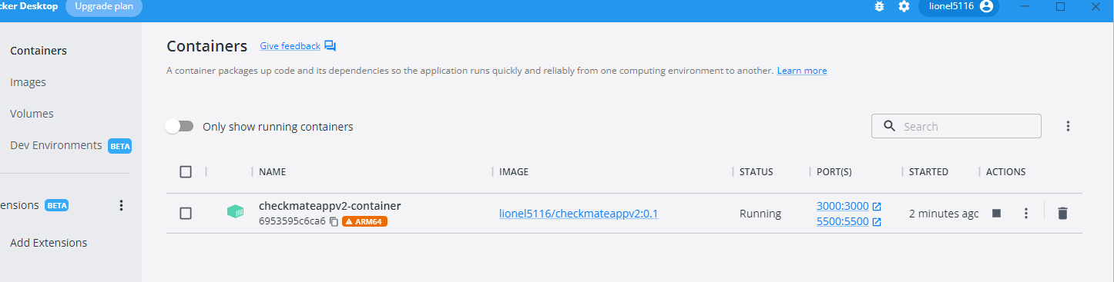The arm64 indicates that we are running it under and arm64 (because we built it on my arm64 mac)  
You can probably specify the processor under a different command. **Now we test:**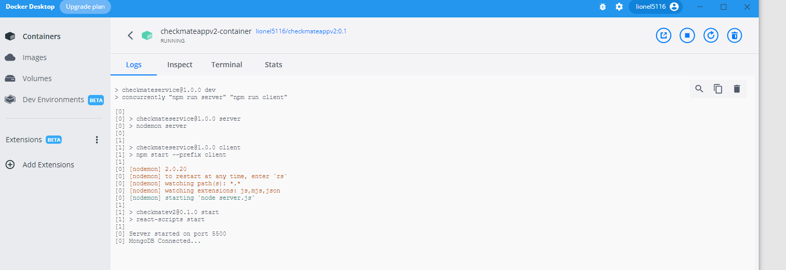

**But it never completed mounted (because of the arm64)**

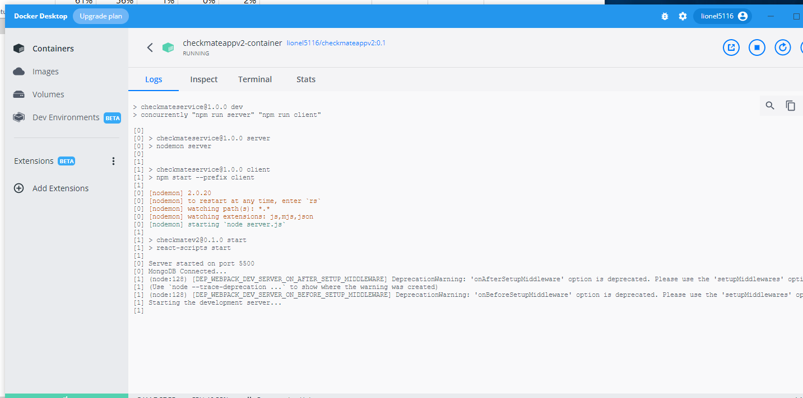 **So in a nutshell, if you built it on windows and pushed it out the registry, it would perform normally.**

**Tip**: Clearing the Git Credentials  
Tip: pulling the Docker Image from the

**Tip**: Clearing the Git Credentials  
git config --global --unset credential.helper  
git config --global user.email "[lioneljones5116@gmail.com](mailto:lioneljones5116@gmail.com)"

**Tip**: BootStrapReact imports for CSV (the correct ones to use to keep from getting errors with table-next)  
These are on the Reports Components. For some reason with the current version of react, it seems to cause a lot of compile/script errors and will not render unless you have the imports shown below.  
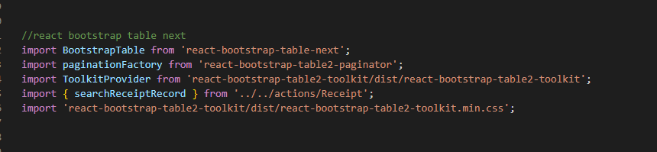  
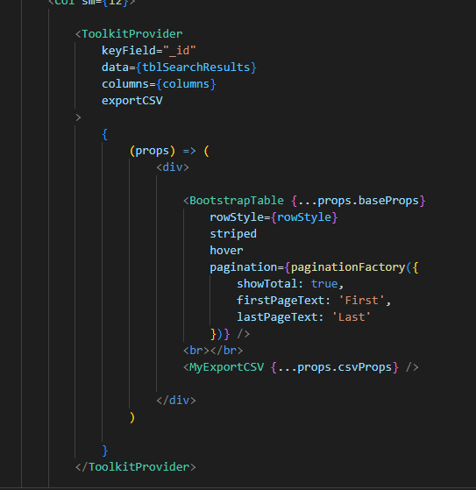

**Tip**: Debugging using Chrome DevTools (Without requiring webpack.config file)  
When debugging local, the source can be found here:  
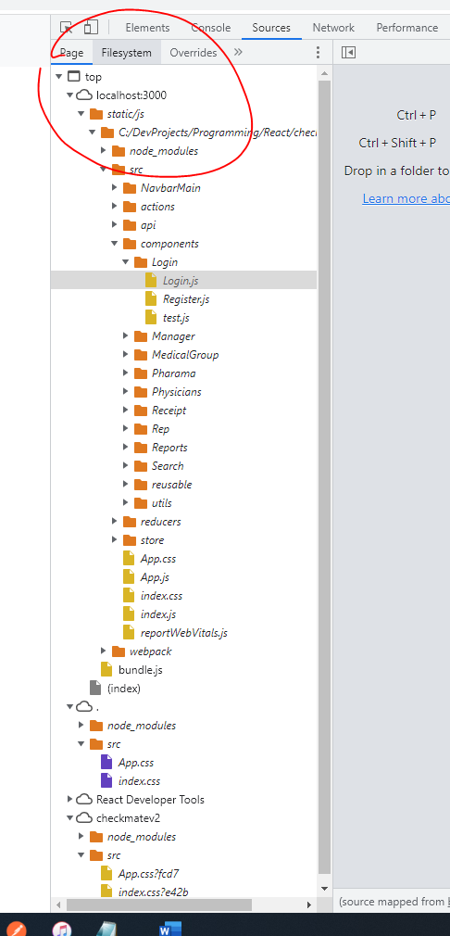  
  
When debugging from a deployed app:

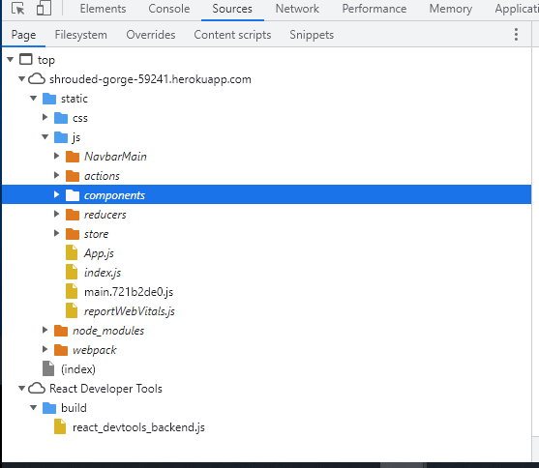  
  
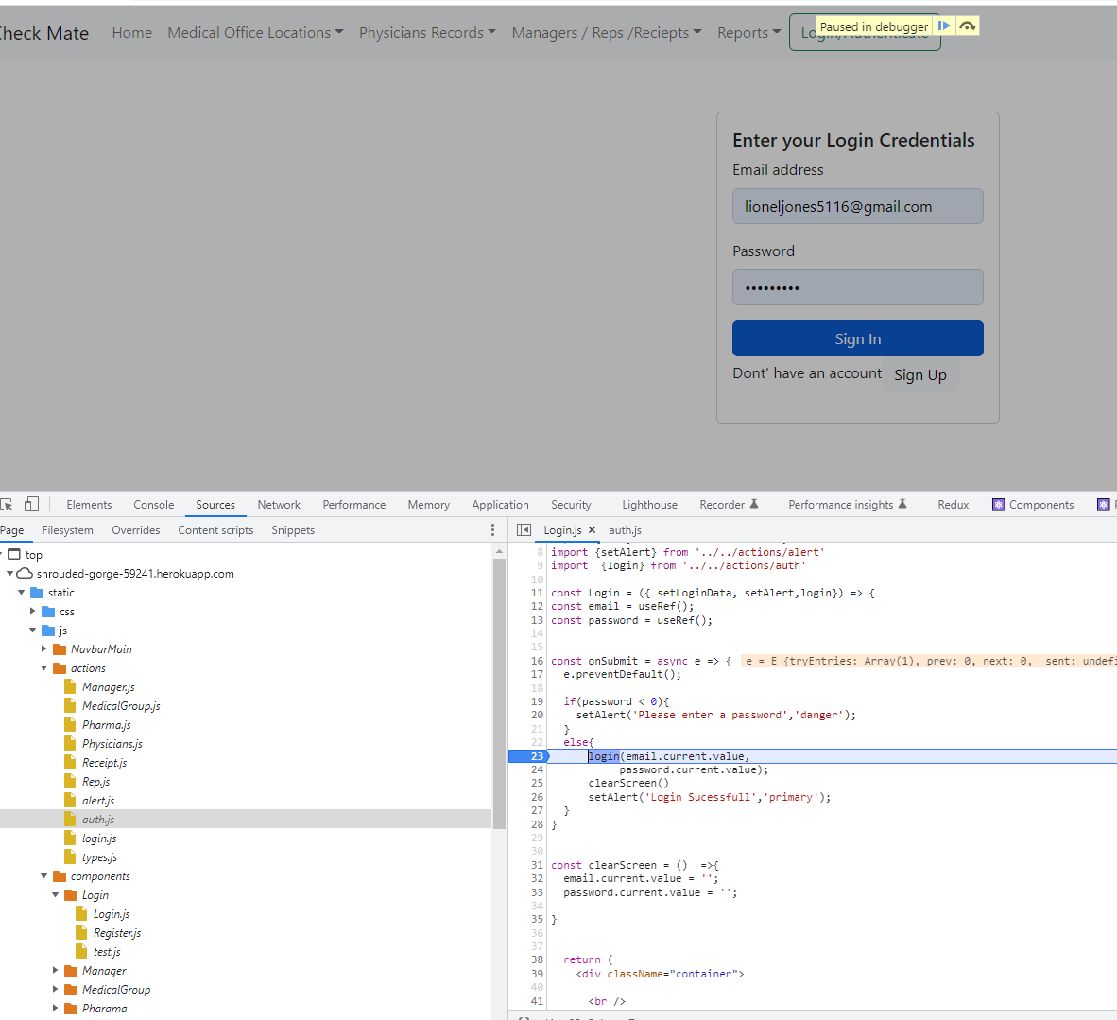

**Tip**: Fixing the issue with warning messages from reactbootstrap next table  
When working with bootstrapnext table, if you get the controlid needs to be unique …, the way you fix it is: (You have to make sure that each column has a unique datafield name), for the edit columns, just add a 1 and 2 for datafield) because we are not surfacing up any data for them anyway, we are formatting them with font awesome images.  
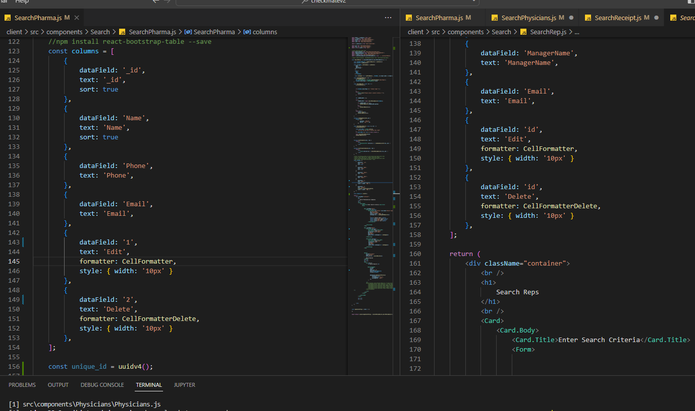  
  
You also need to make sure this is correct as well  
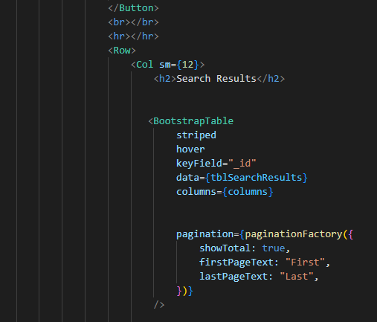  
The key field needs to be the _id field (needs to be unique)

**Tip**: Enabling Authorization – JWT and REDUX – hiding the navigation based on REDUX  
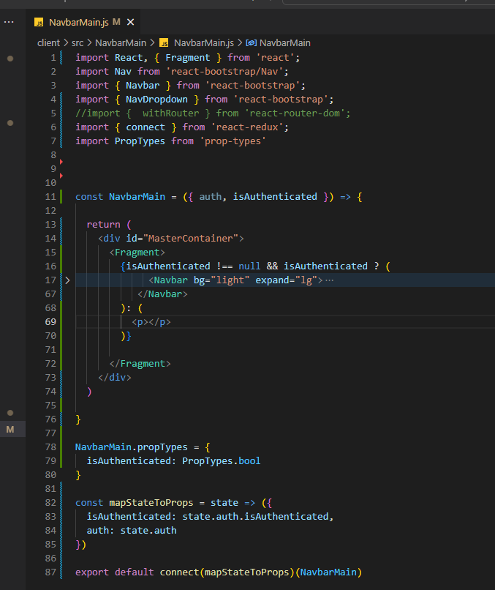  
  
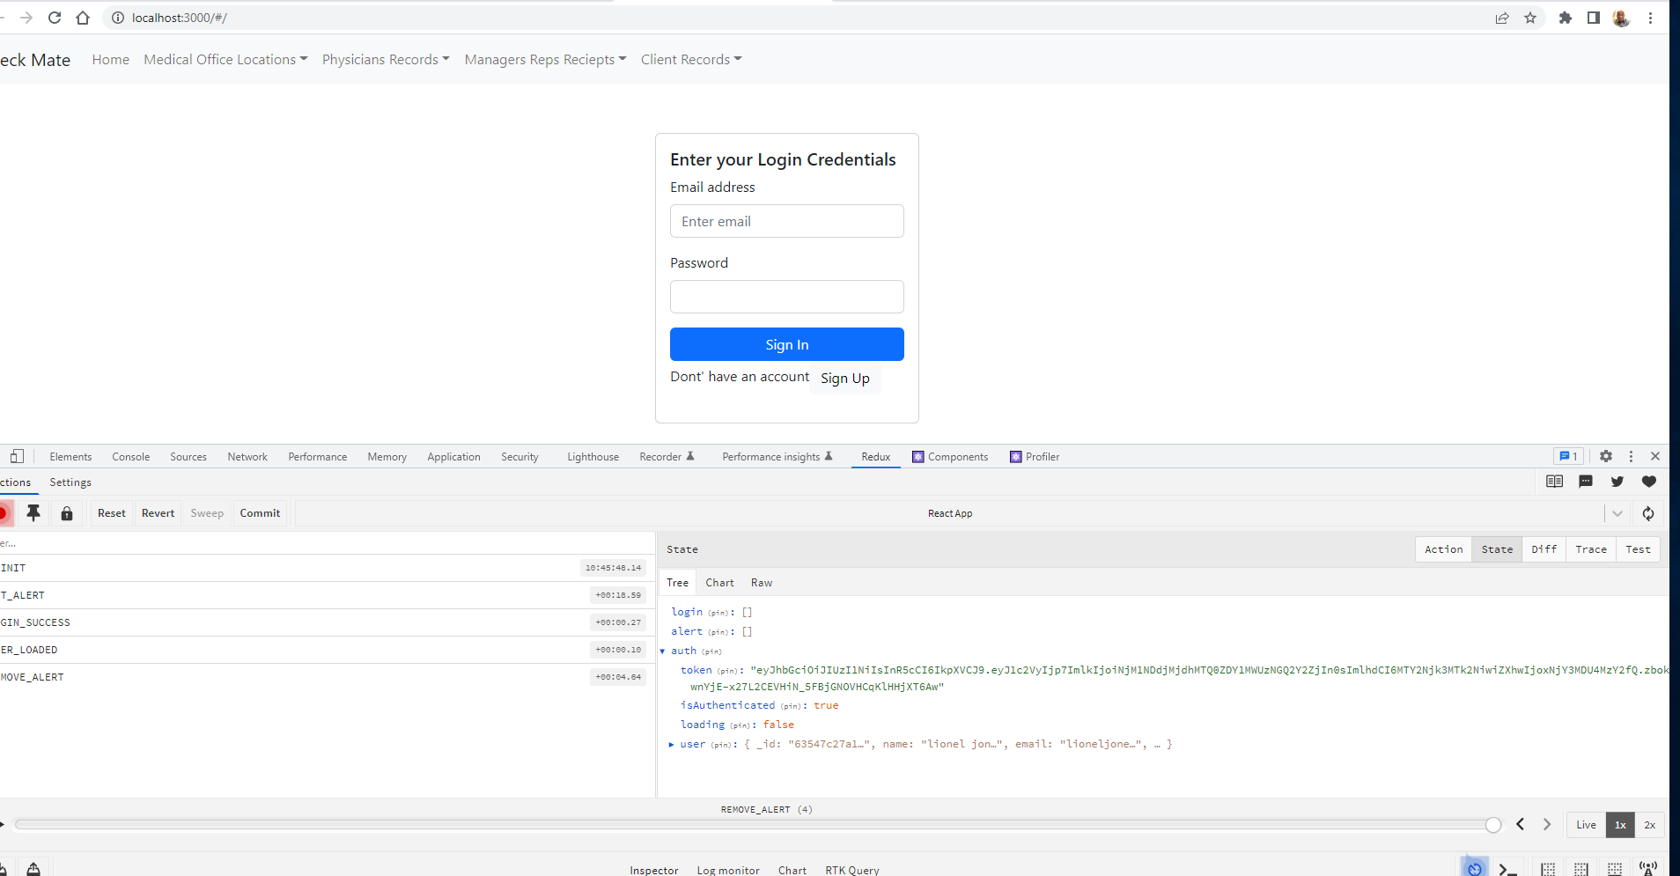

**Tip**: Comparing both versions of CheckMate  
CheckMateV2 is my favorite:  
**Pros**: It’s a smaller bundle (it does not use more webpack (ver 5), it builds 200% faster  
When you make changes, it reloads faster.  
It does crash when you deploy to Heroku  
It's official – Going with V2 – It deployed to Heroku – no errors and figuring out this culprit  
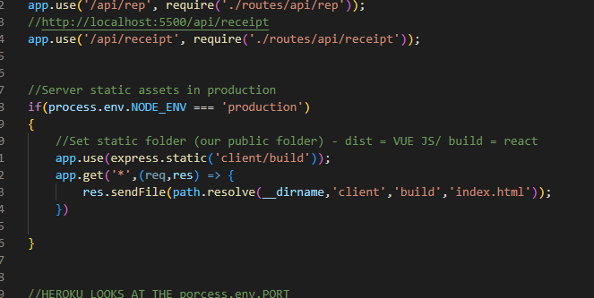  
  
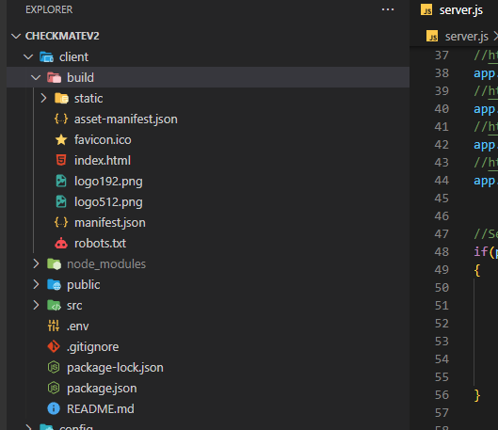  
  
**Cons:**  
It has a huge set of warnings with bootstraptablenext (but it still works tho)  
  
I will more than likely go with CheckMateV2 for the pass-off (It will be a lot easier for the devs to work with in terms of deployment)

**Tip**: Using uncontrolled components  
Sometimes react acts weird with controlled components, in this case we can use uncontrolled components  
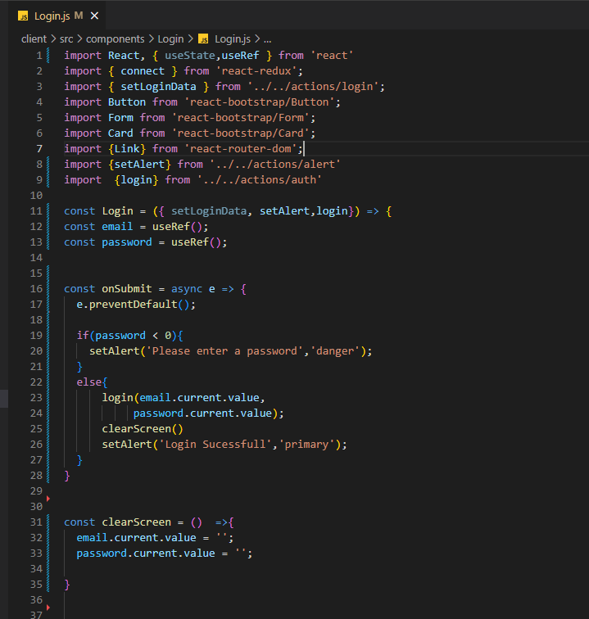  
  
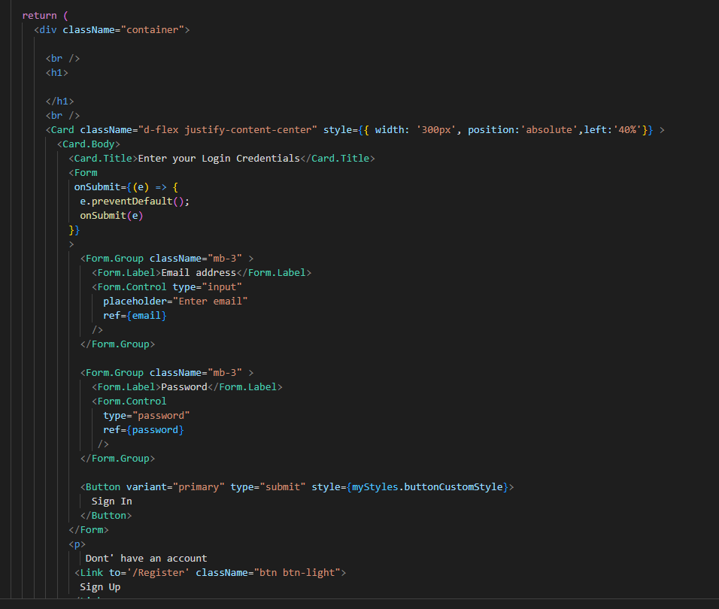  
  
  
  
  
  
<https://shrouded-gorge-59241.herokuapp.com/#/>

**Tip**: Adding styles to the login screen  
  
Look at the style for the card, this was used to center using absolute and flex  
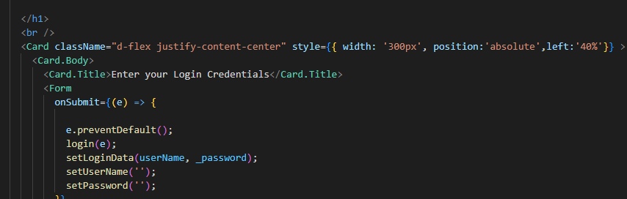  
  
For the button, we use width: 100%  
Position: absolute relative to the screen size, and it works with the left attribute (40% of the screen)  
d-flex justify…. Is from bootstrap 5- see the docs  
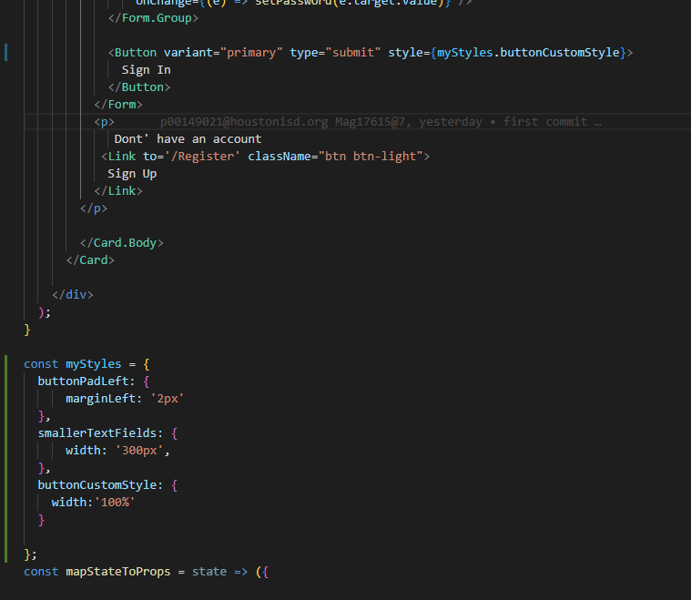  
  
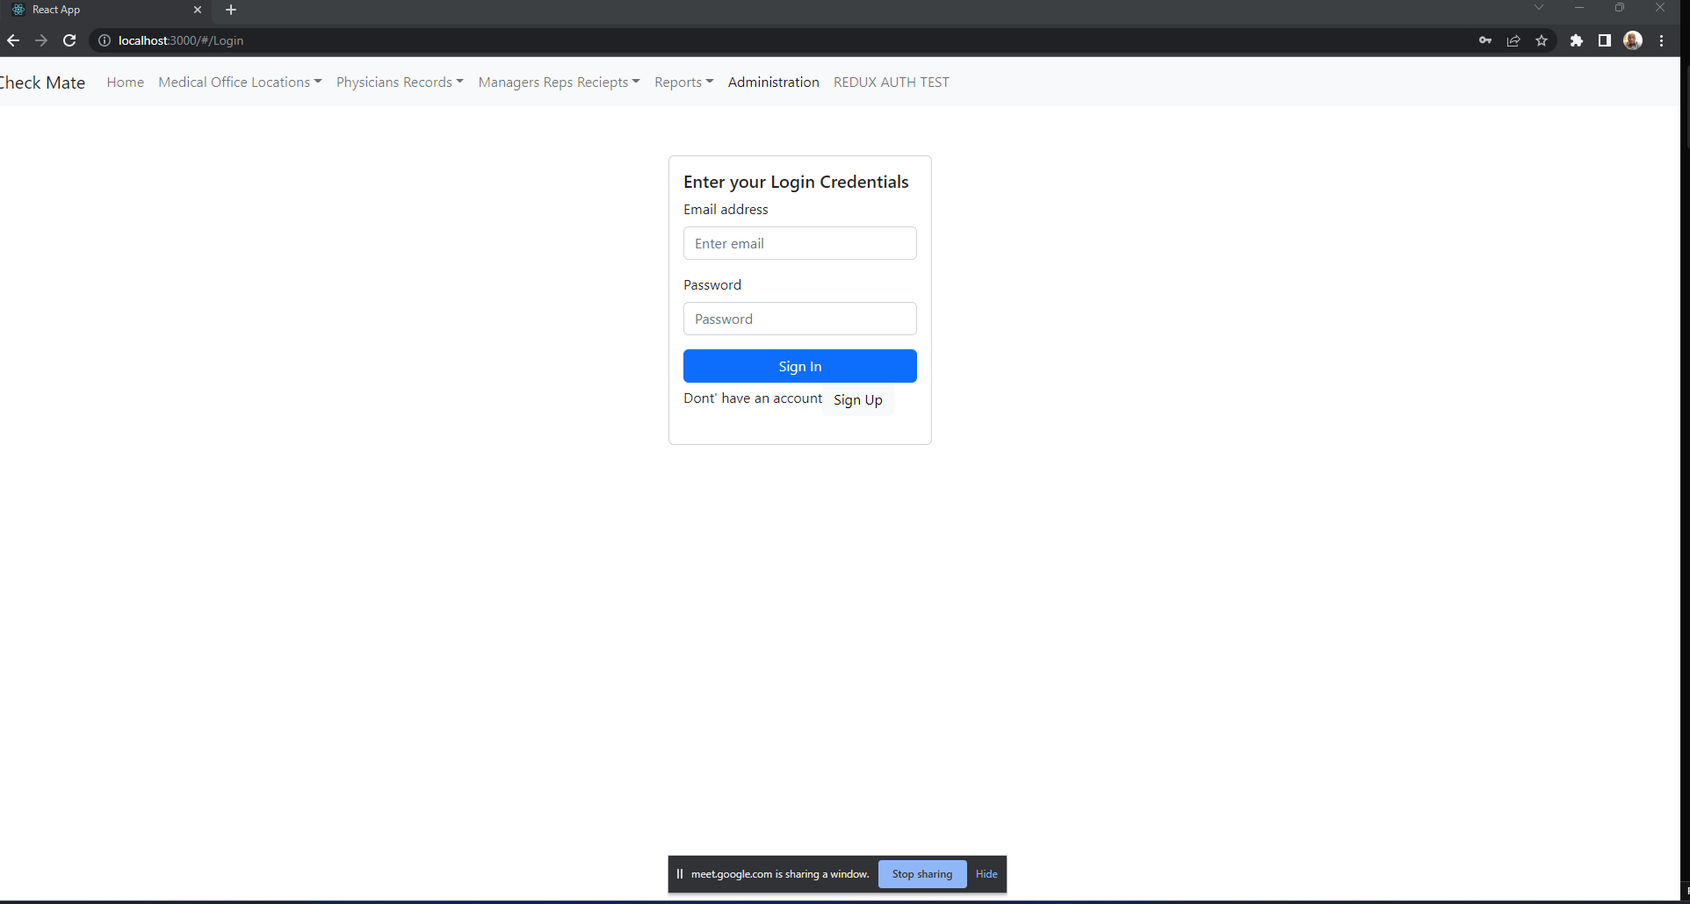

**Tip**: Splitting out the webservice to Heroku  
Web service URL  
https://pure-gorge-49930.herokuapp.com/  
  
Modify your server.js  
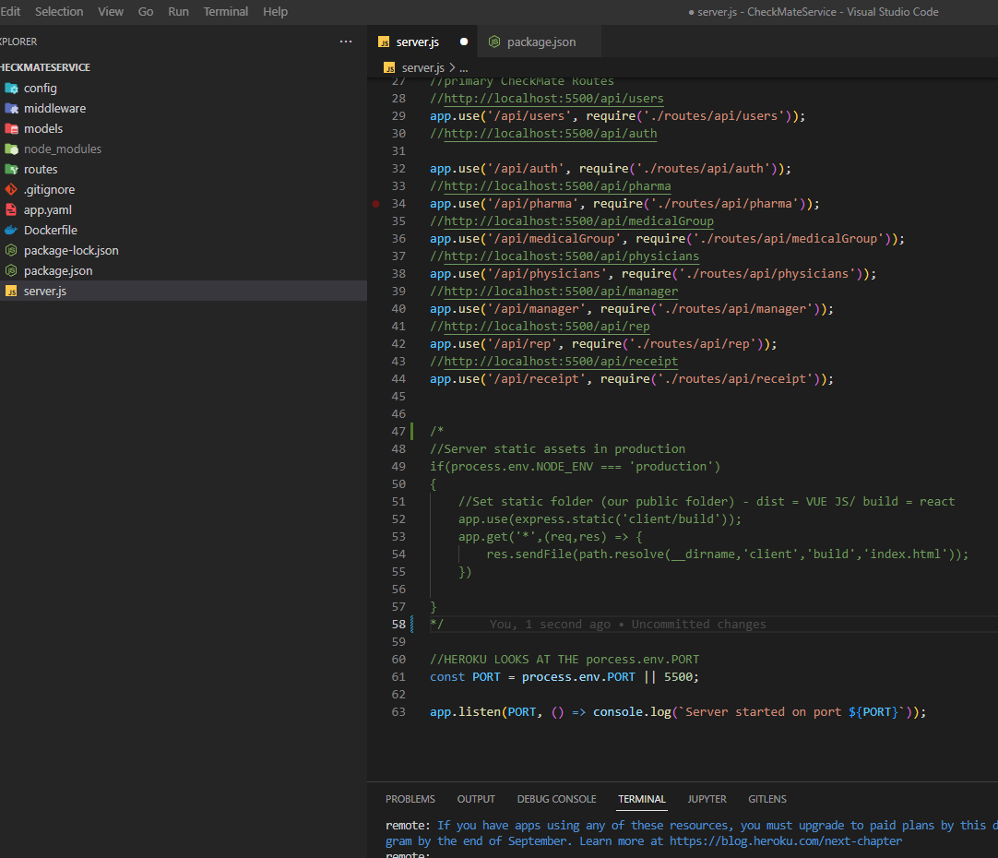  
And your package.json  
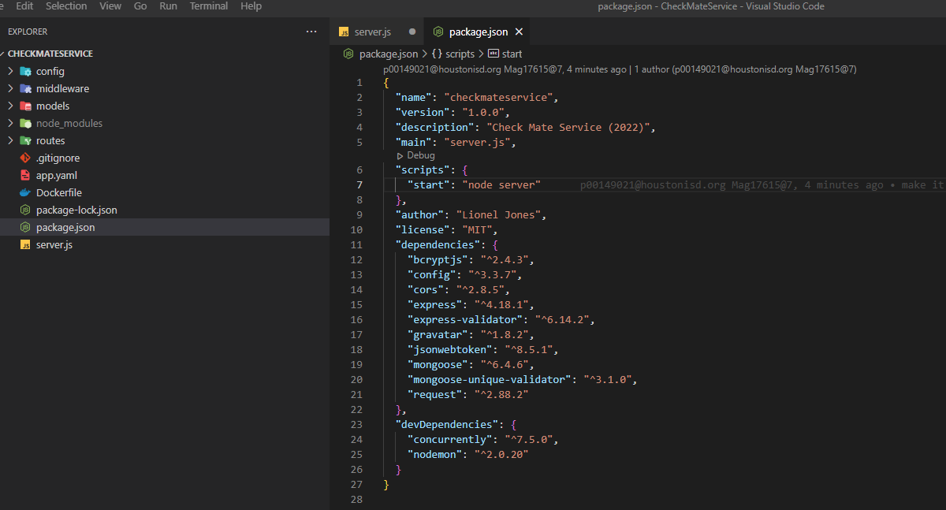  
  
https://pure-gorge-49930.herokuapp.com/api/pharma/searchPharmaRecord  
  
  
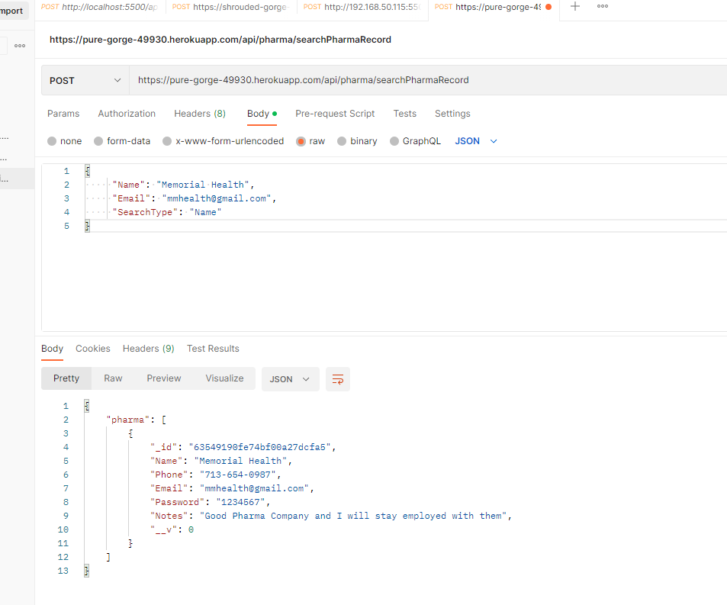  
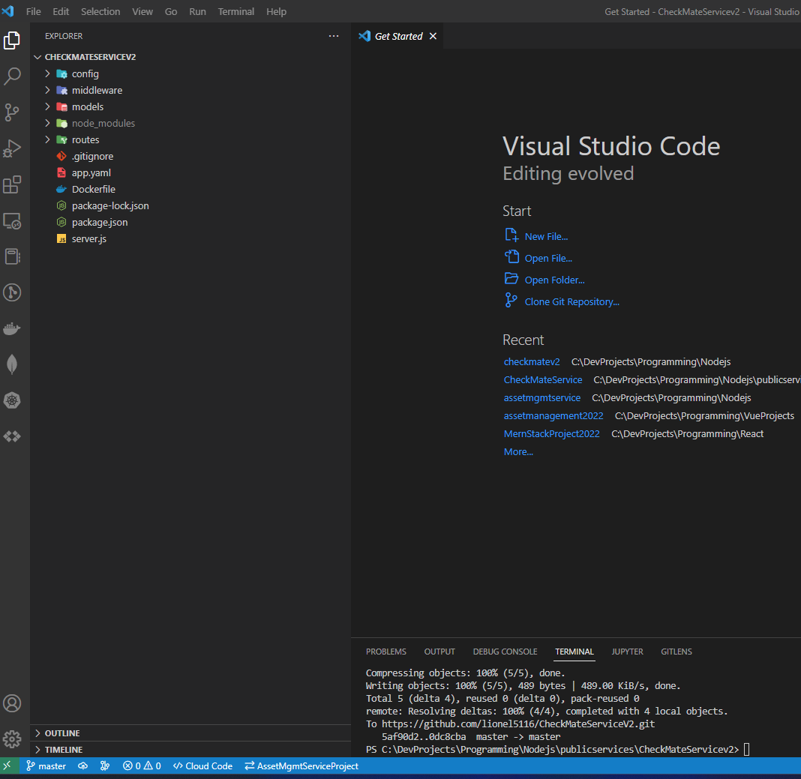

Placed it in the project and it works  
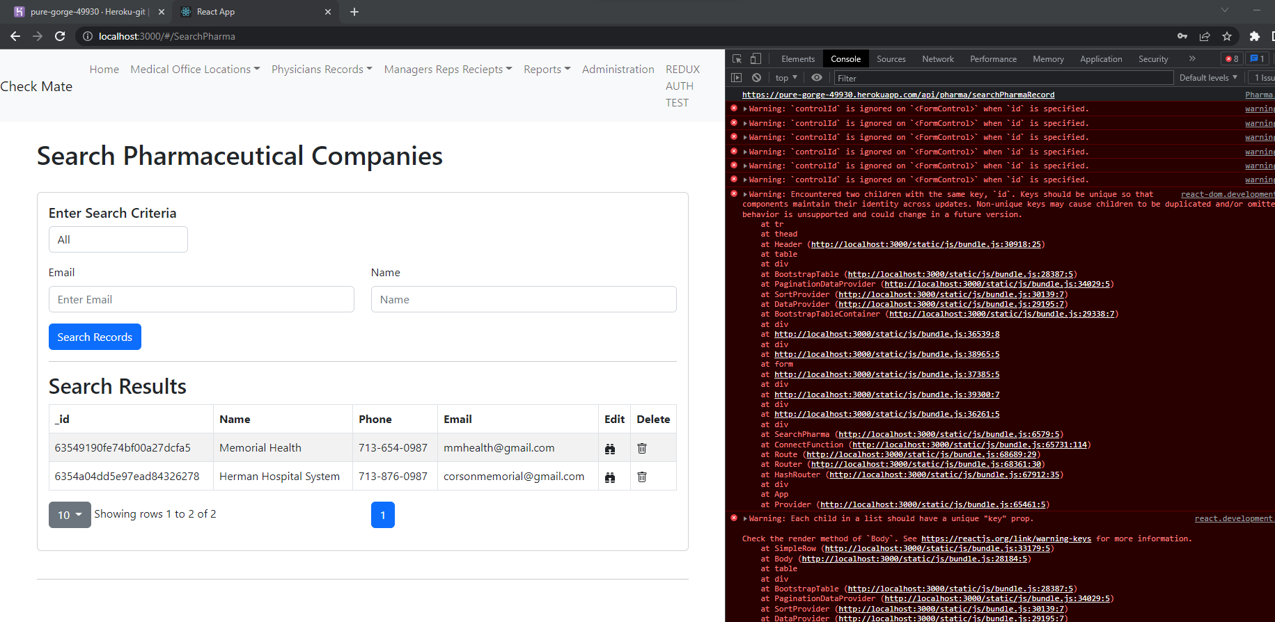  
  
Changed url to point to the service on Heroku  
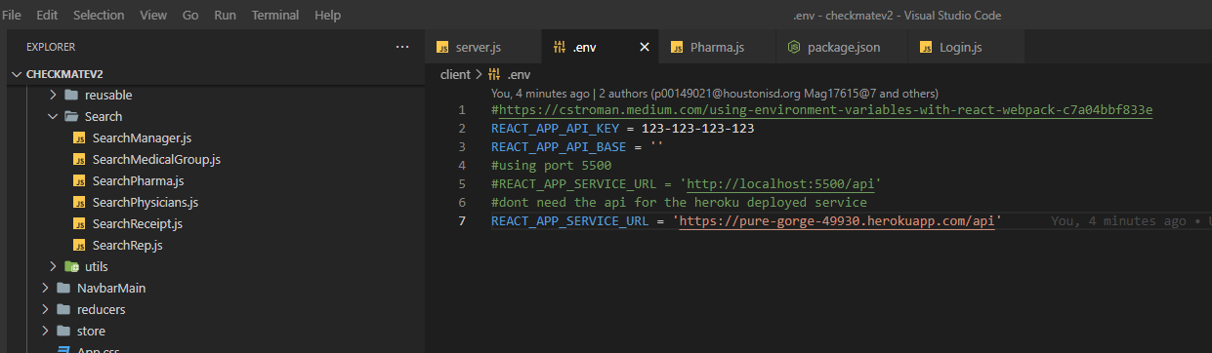  
  
And it works!!!!  
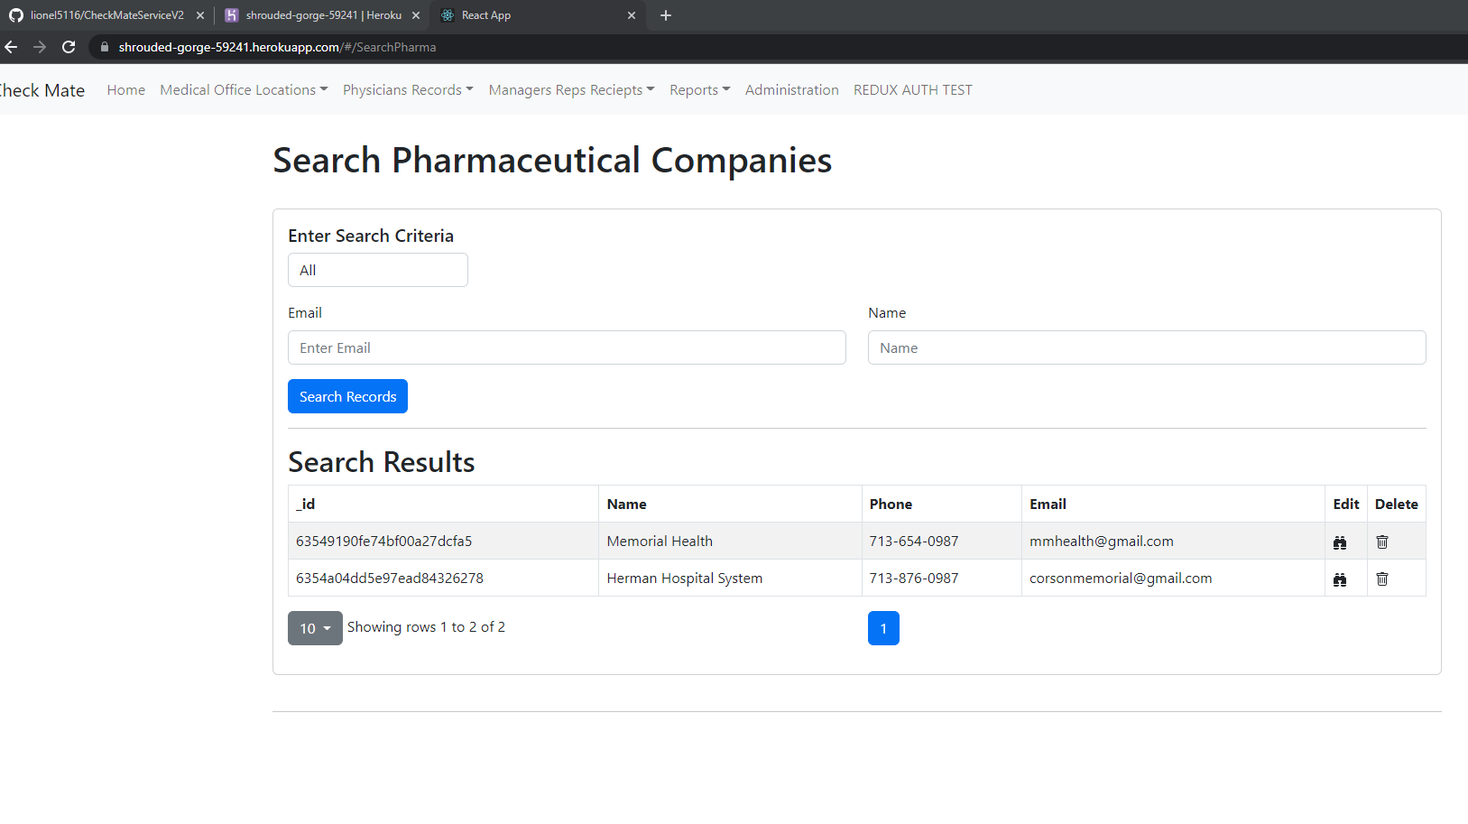

**Tip**: Deploying to Heroku (Got it to work)

Deploying to Heroku is super easy!!!  
Most important step, do a build first to see where what your build location is:  
npm run build

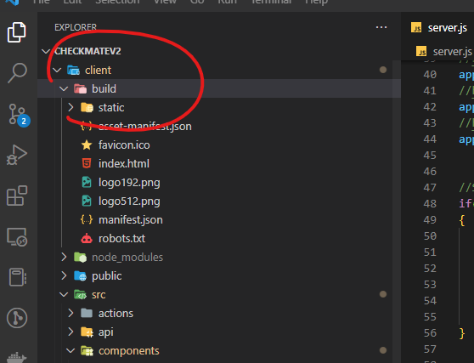

This determines lines 48 and 51 below   
I made this mistake before, the /dist folder is when you are building a VUEJS app, like my assetmgmt2022 **creates VERY IMPORTANT !!!!!!!**

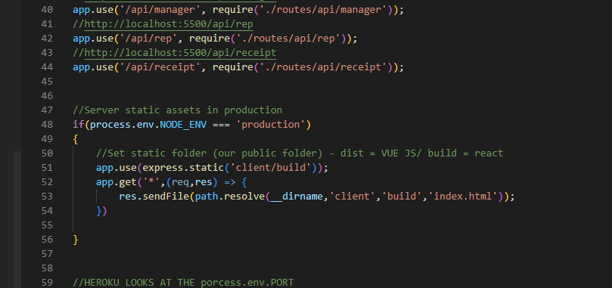

Next you do:  
Heroku login  
Heroku create  
  
It creates a repo  
Go to deploy on the dashboard  
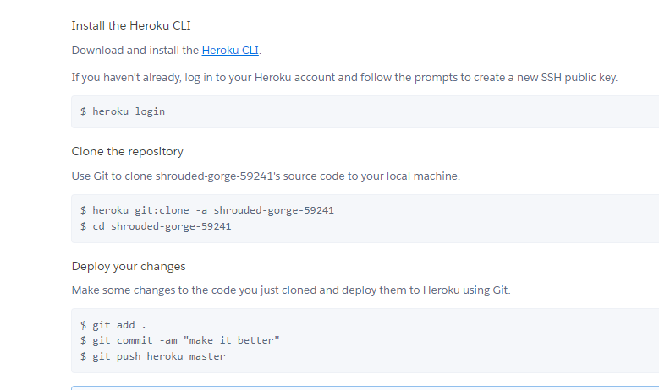  
Follow the instructions, do a  
heroku git:remote -a shrouded-gorge-59241

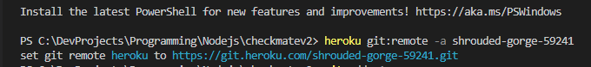

**Then do a**   
git add .

git commit -am "make it better"

git push heroku master

And there you go  
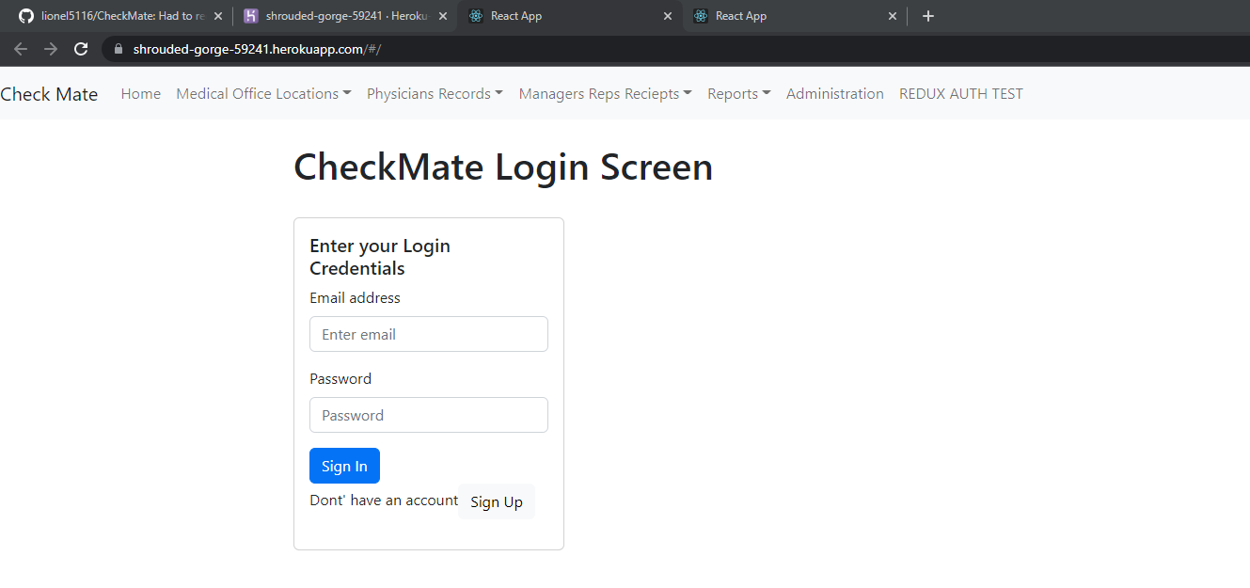  
  
https://shrouded-gorge-59241.herokuapp.com/#/  
Ahd it WORKS!!!!!  
It took time for the service to start (I hit the endpoint to quick)  
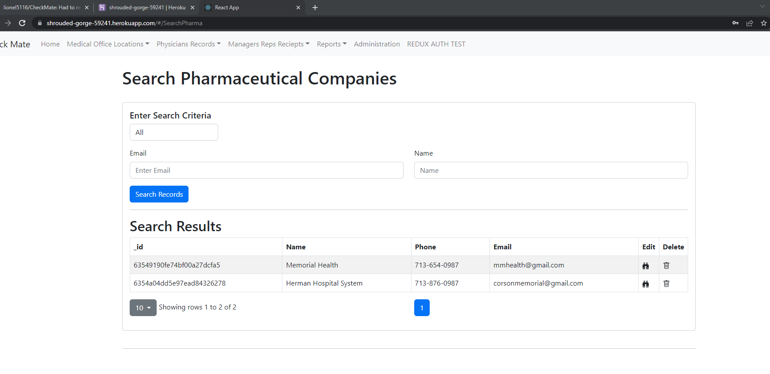

**Tip**: Getting the solution run in a docker container

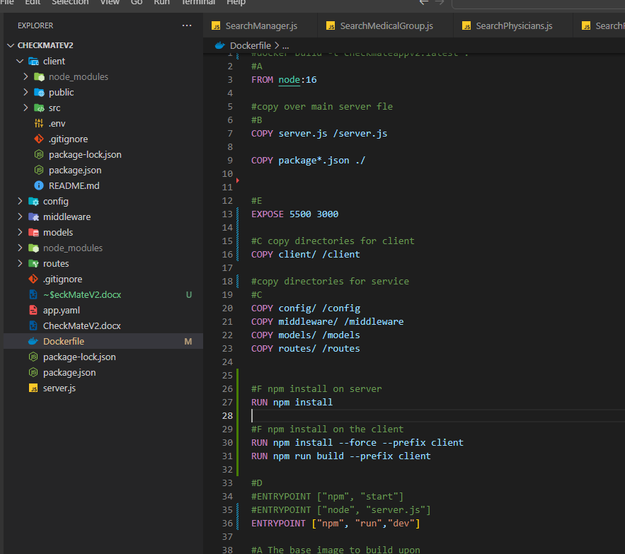  
  
Notice line 13, this is how you expose both ports  
3000 is for the client app  
5500 is for the NodeJS app  
  
Line 16 is copying the client folder’s contents  
  
line 30 ad 31 runs the install and build of the react app  
  
line 36 runs your custom command – (npm run dev)  
  
To run the image

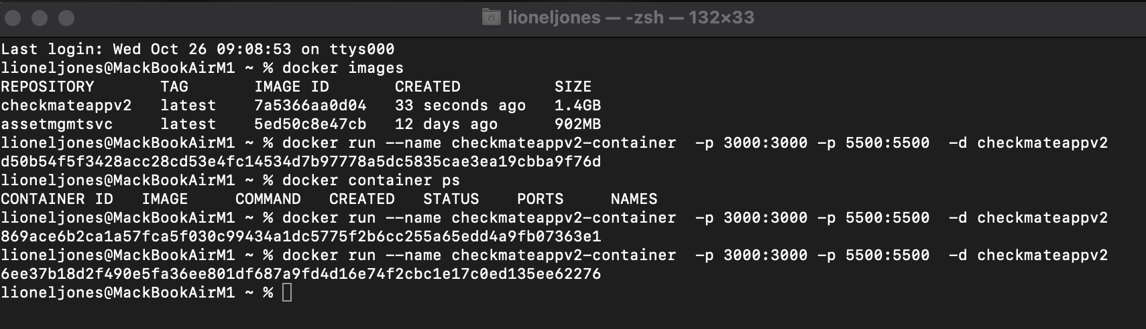  
  
To run the image  
docker run --name checkmateappv2-container -p 3000:3000 -p 5500:5500 -d checkmateappv2  
  
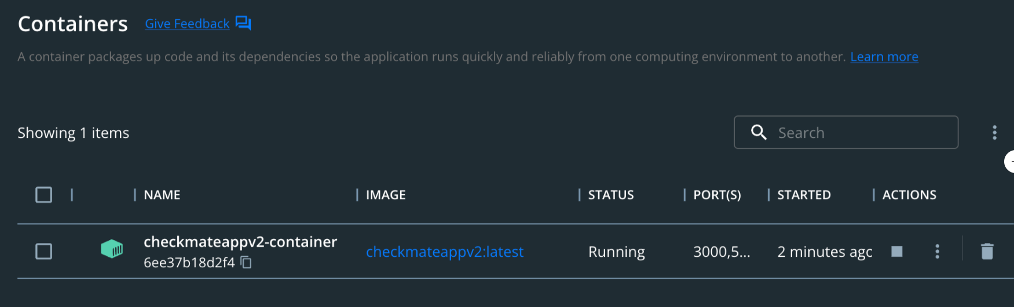  
  
And it works

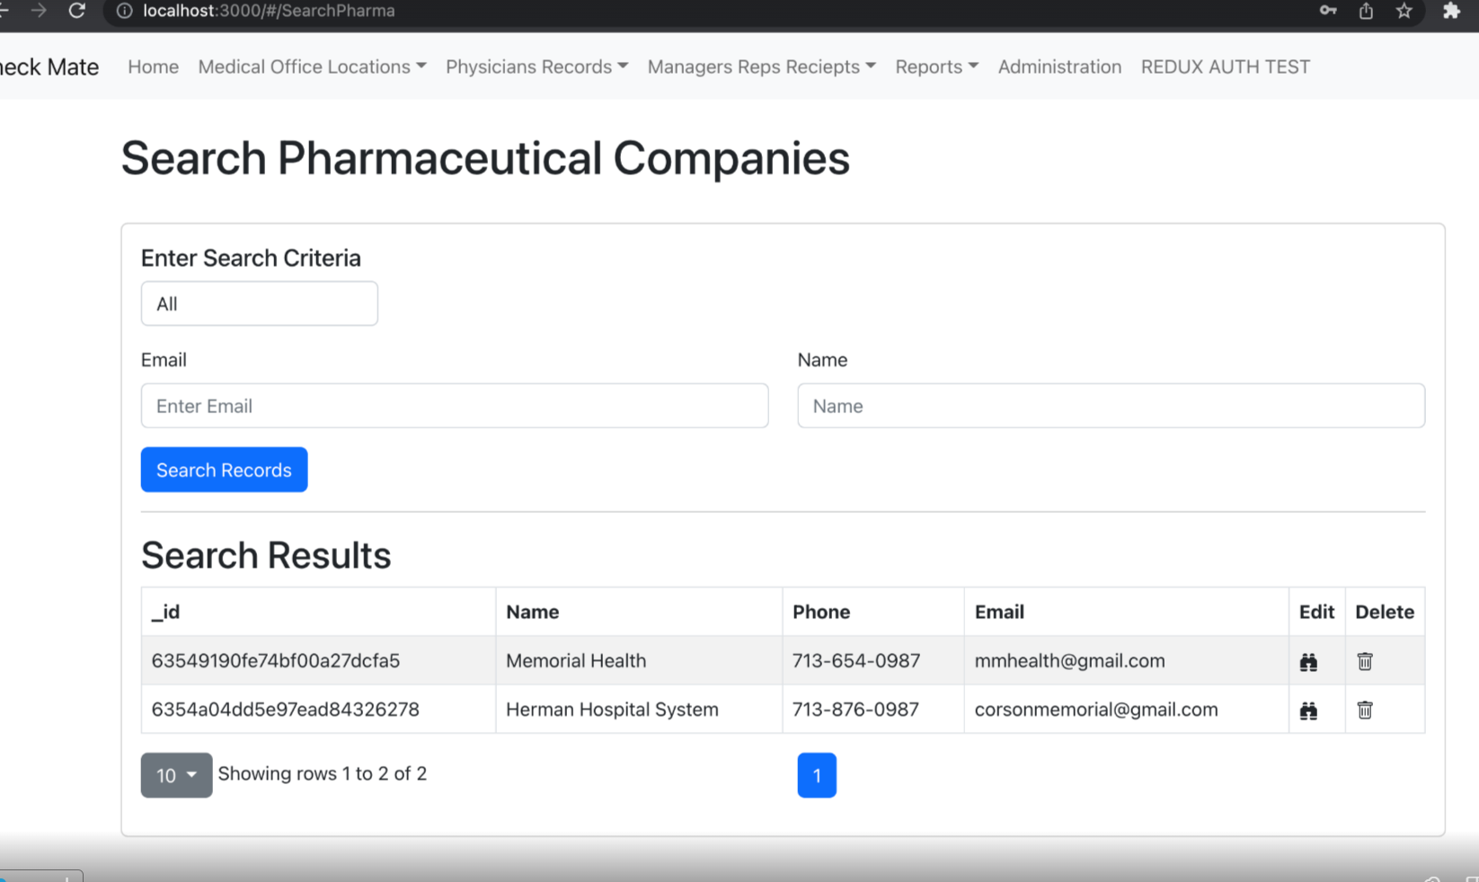  
  
**To run your image**  
docker run --name checkmateappv2-container -p 3000:3000 -p 5500:5500 -d checkmateappv2

docker inspect checkmateappv2-container  
  
To grab the id only  
docker inspect --format =“{{.Id}}” checkmateappv2-container  
  
But I get an error (need to research this)

To remove your image  
docker rm 6ee37b18d2f490e5fa36ee801df687a9fd4d16e74f2cbc1e17c0ed135ee62276

Below is the end user process  
If you already have a container that your ran. Then you stopped and restarted your machine. The container maintains it’s id and configuration. You will see it below  
  
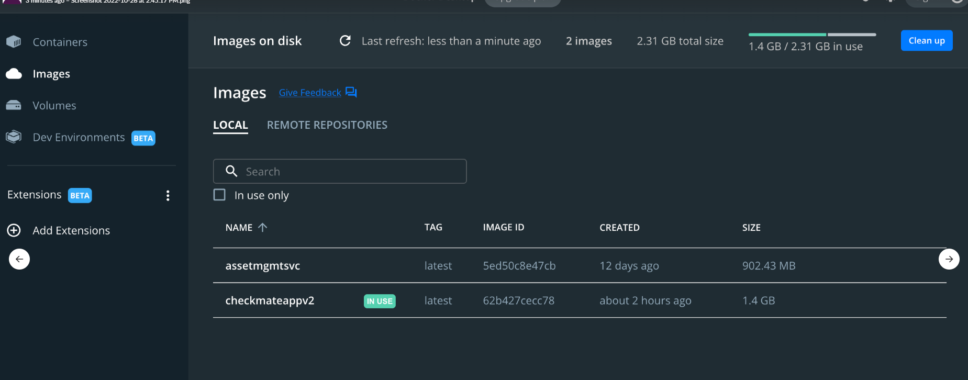

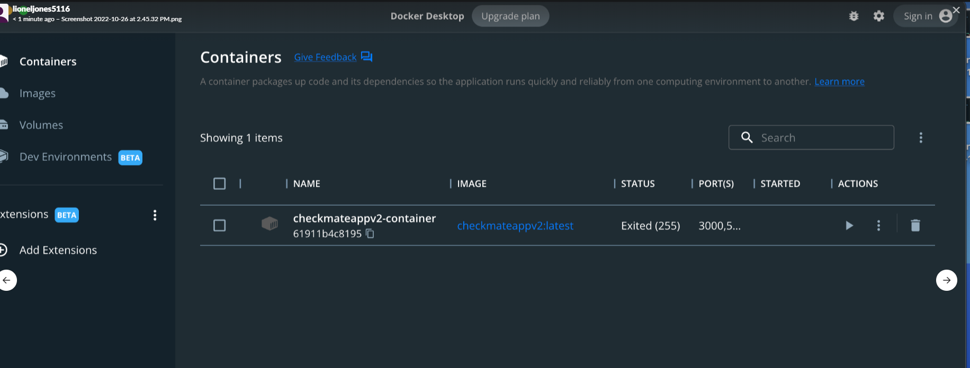  
  
Just hit the start button  
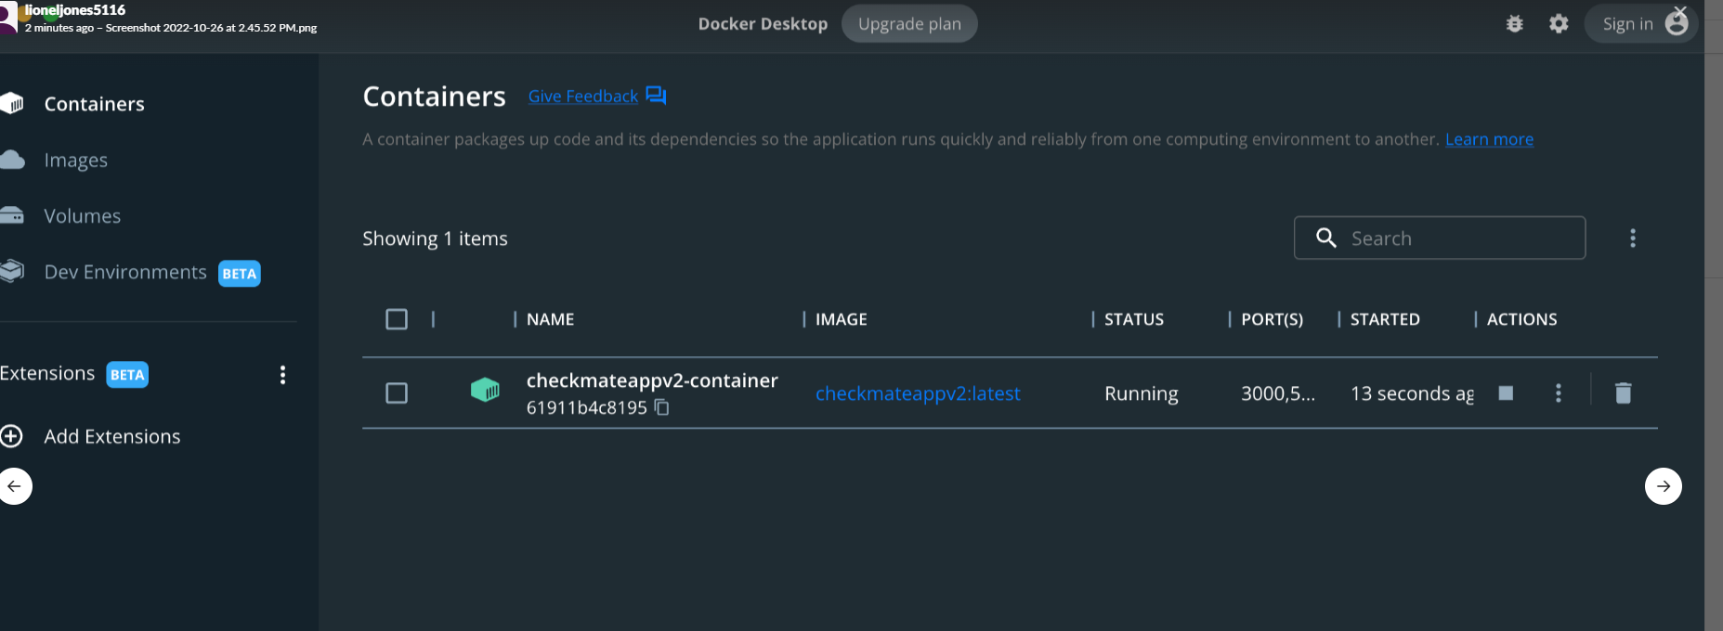  
  
And as you can see below, it still has it’s settings  
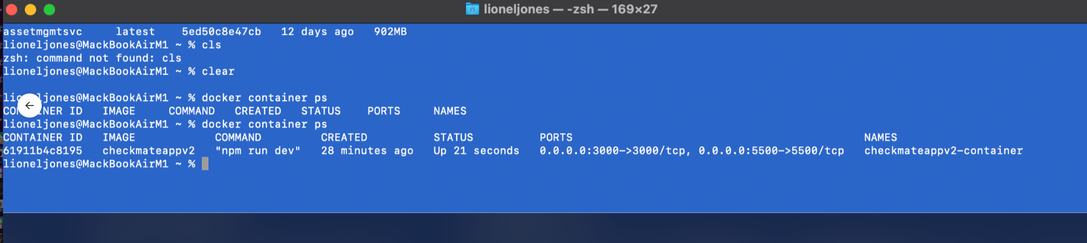  
  
  
Then I did a test from my MAC at home:  
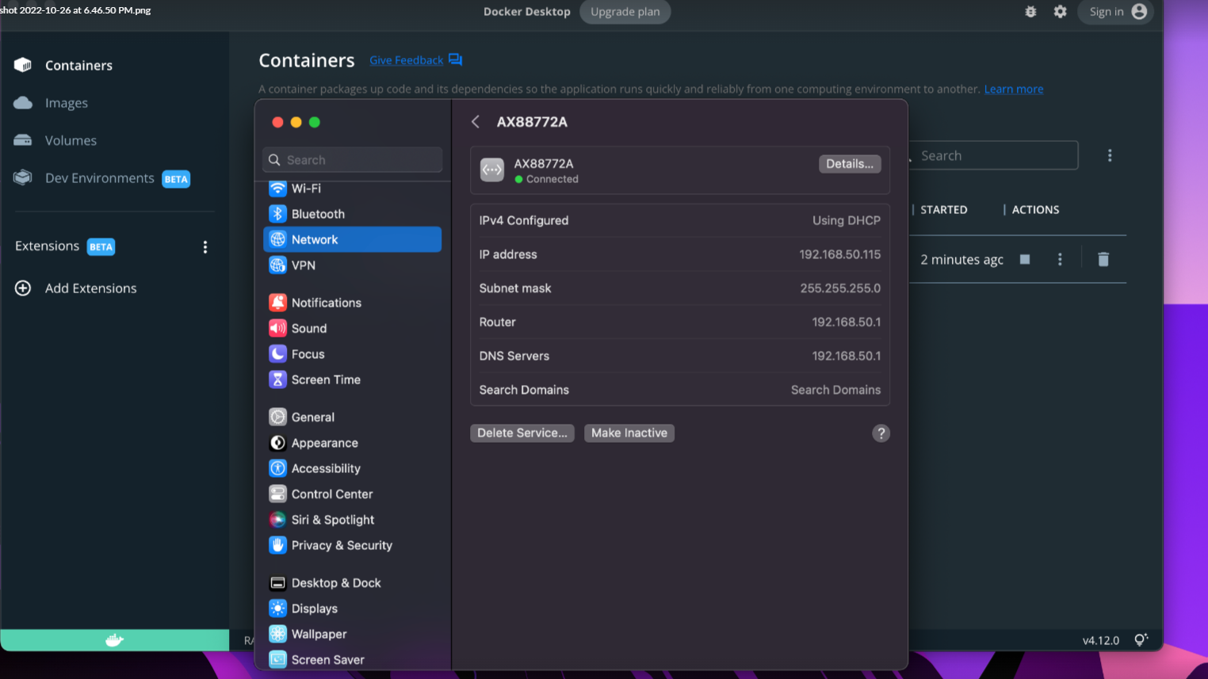  
  
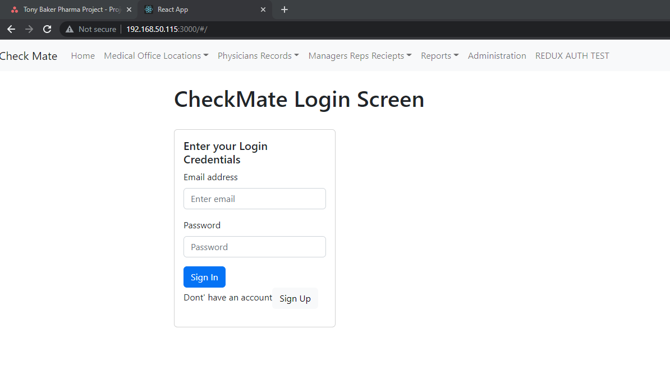

But it’s looking at localhost  
Now if you wanted to use the service  
This works:  
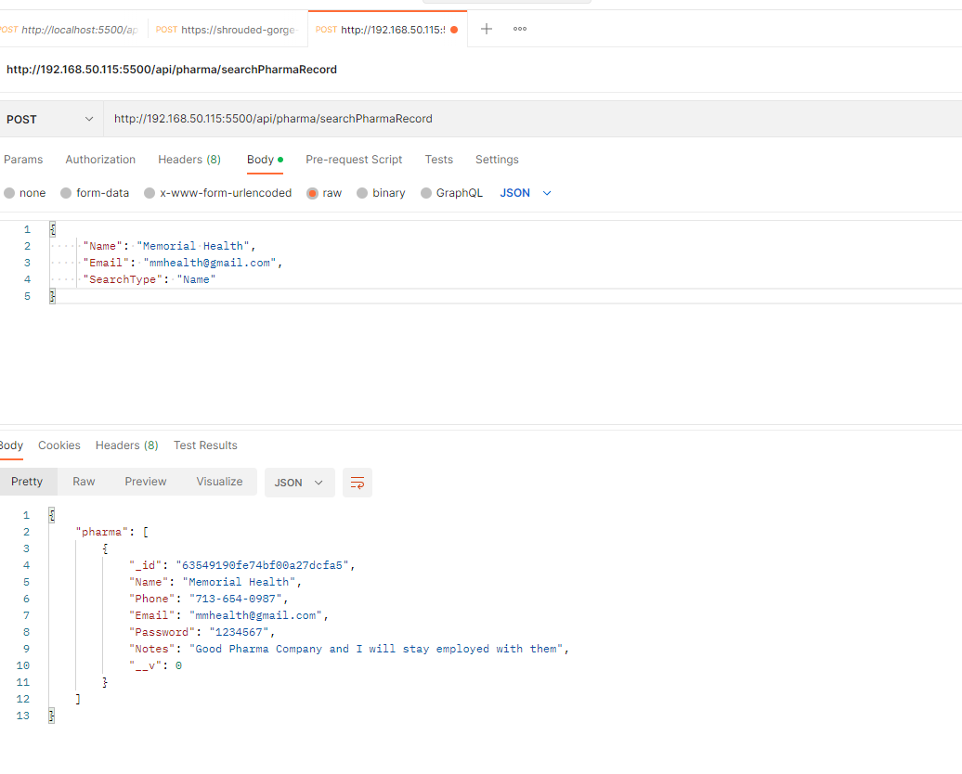  
  
But the app itself points to localhost (meaning that it thinks it’s looking itself)  
  
**Tip**: Pushing the image to Docker Public Registry  
First you have to tag your image  
docker tag checkmateappv2 lionel5116/ checkmateappv2:0.1  
  
Then login to docker:  
docker login -u lionel5116 docker.io  
  
Then to push to the docker public registry  
docker push lionel5116/ checkmateappv2:0.1  
  
  
  
  
  
  
  
When you tag the image, it creates another (pointer) to the same image (not a copy)  
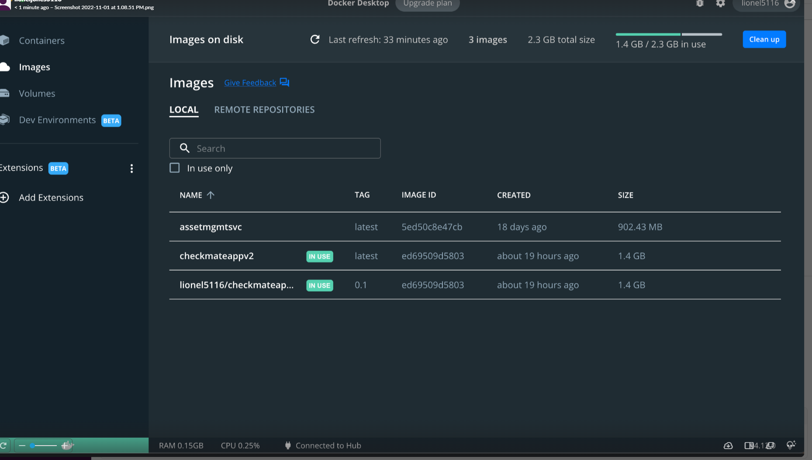  
  
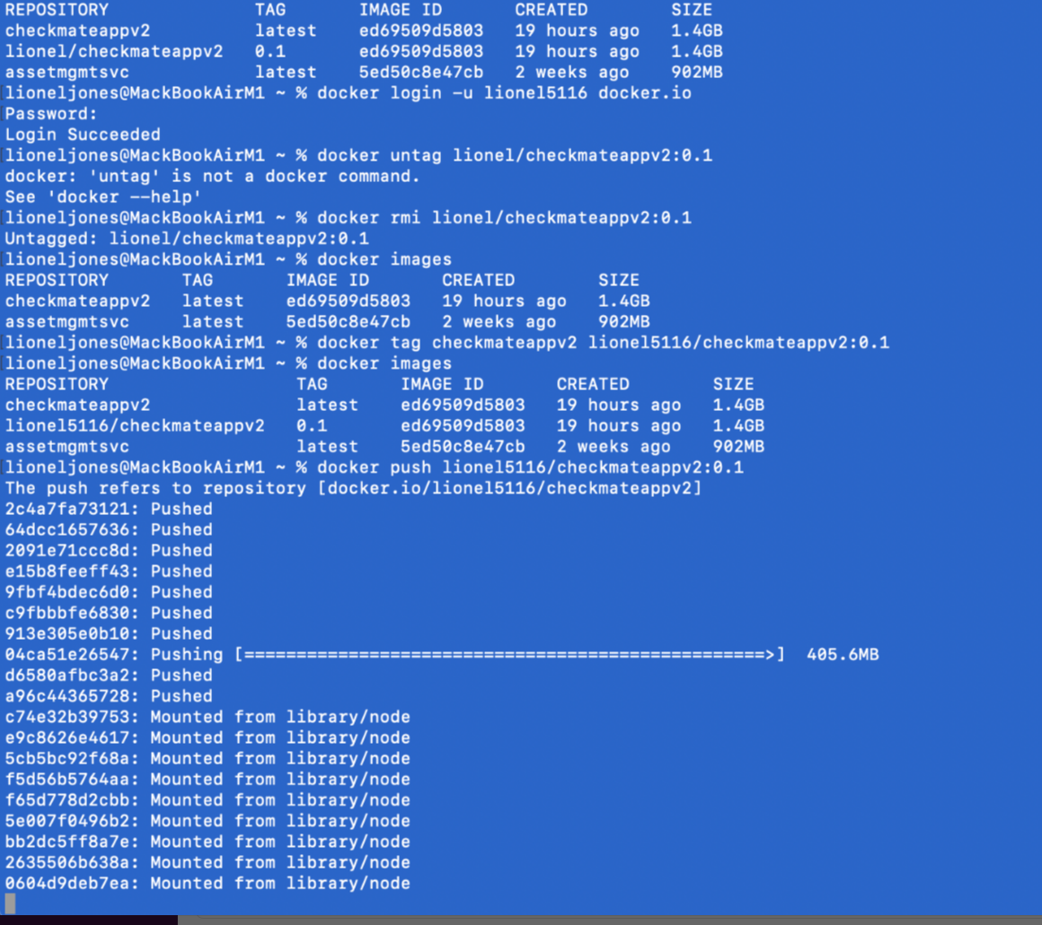

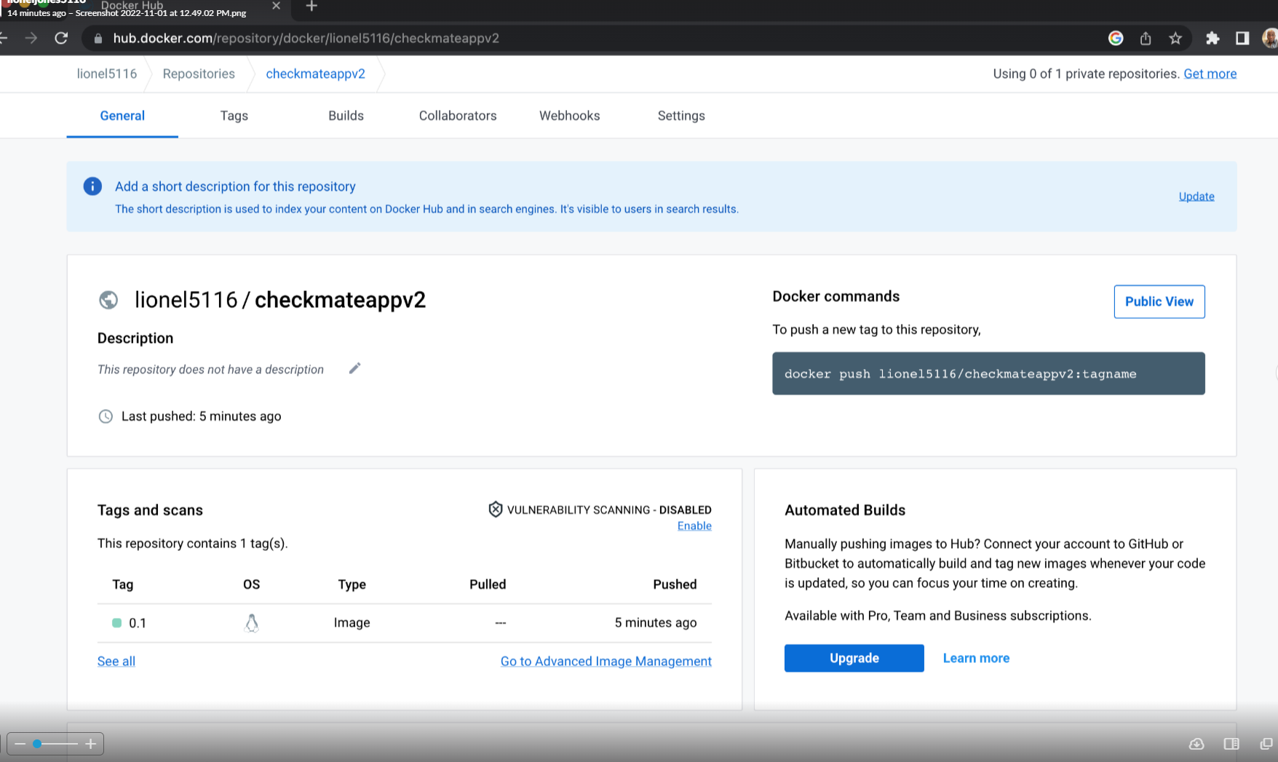

**To pull the image**  
  
docker pull lionel5116/checkmateapp2

**Tip**: Using Google Meet for meetings  
Google meet rocks.. it’s free and much easier to use than teams, and it’s completely free  
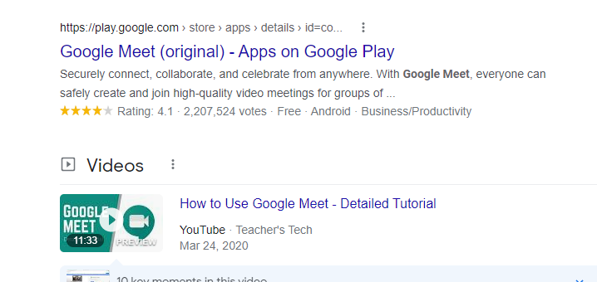

**Tip**: Running VSCode from command in terminal on mac m1  
https://code.visualstudio.com/docs/setup/mac#:~:text=You%20can%20also%20run%20VS,code'%20command%20in%20PATH%20command.  
  
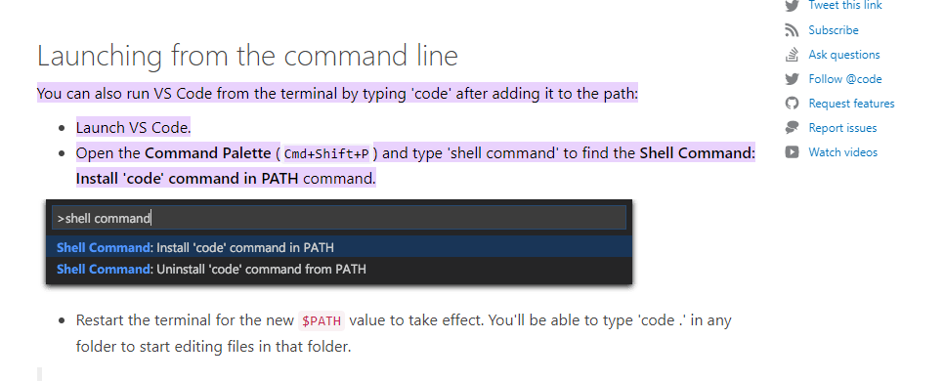

**Tip**: Comparing both versions of CheckMate  
CheckMateV2 is my favorite:  
**Pros**: It’s a smaller bundle (it does not use more webpack (ver 5), it builds 200% faster  
When you make changes, it reloads faster.  
It does crash when you deploy to Heroku  
  
**Cons:**  
It has a huge set of warnings with bootstraptablenext (but it still works tho)

**Tip**: Fixing Macbook deploy issues  
For the error below when trying to clone the repo

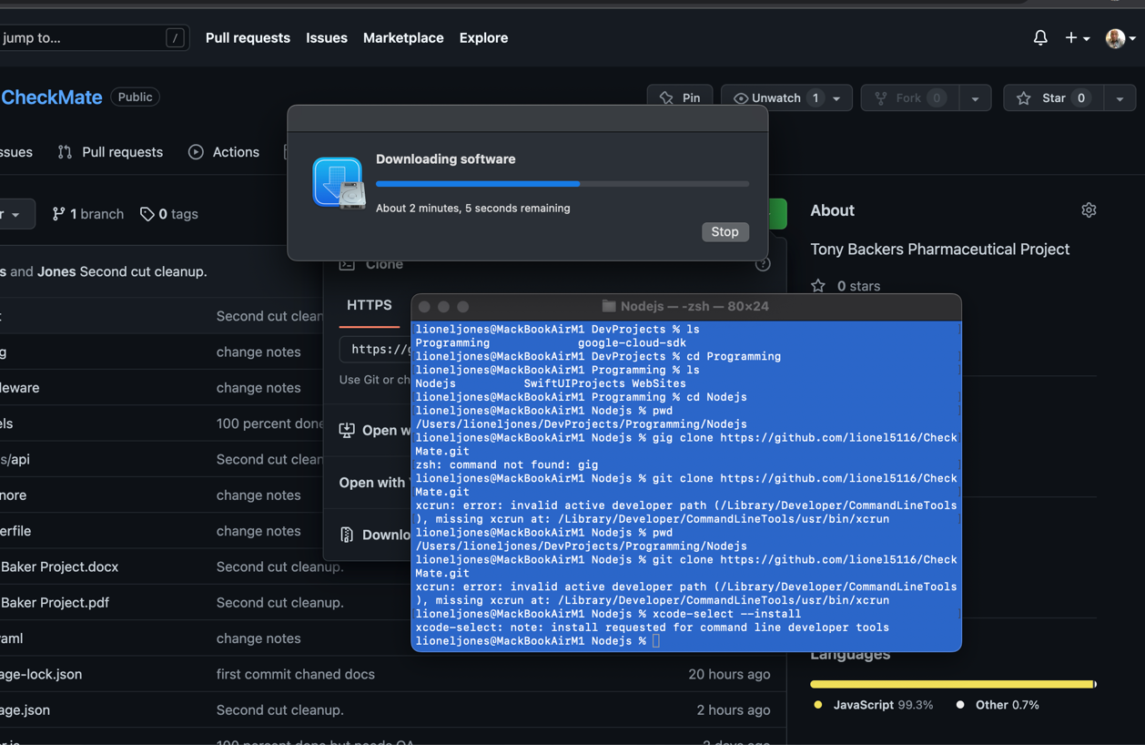  
  
I had to run the command to update my xcode tools  
xcode-select –install  
  
This is common everywhere  
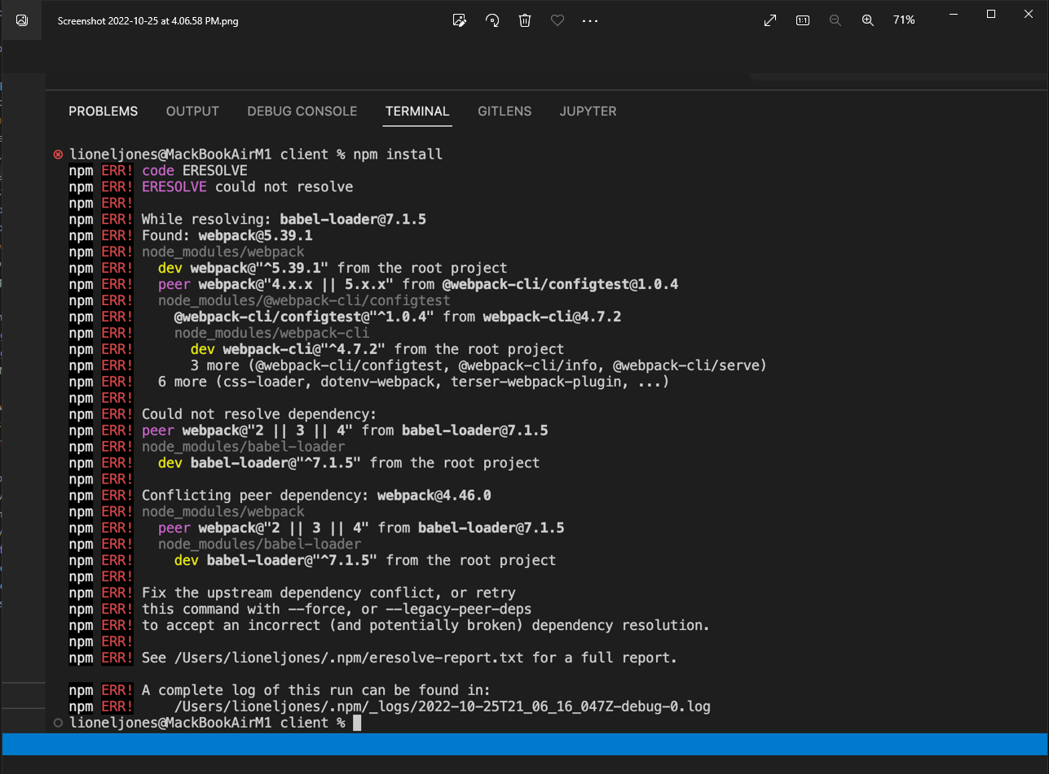  
  
see the message  
npm install –force  
  
I have to use this everywhere, even in my deploy scripts for Heroku

**Tip**: Fixing this error: - options.allowedHosts[0] should be a non-empty string  
While doing npm run start, I was getting ERRORS , no matter what I did. The way I fixed it was to   
remove the proxy entry from the package.json file   
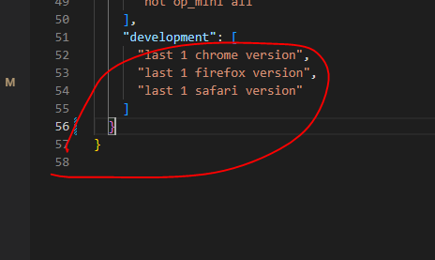  
  
I am not use a proxy anymore anyway.

I decided to create another version of the app without webpack – causing too many issues  
  
<https://reactjs.org/docs/create-a-new-react-app.html>  
  
https://react-bootstrap.github.io/getting-started/introduction/  
  
npm install react-bootstrap bootstrap  
  
In Index.js  
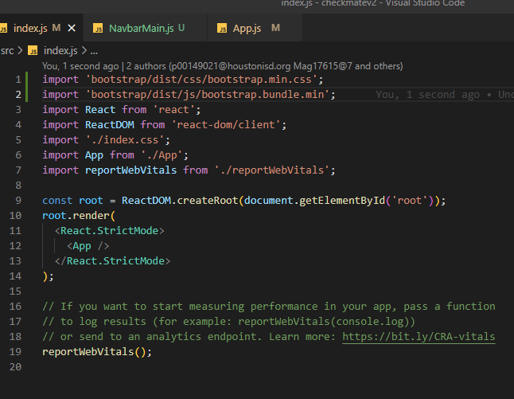  
  
And so far, no warnings  
  
  
  
  
  
npm install react-router-dom –save  
  
npm install react-router-dom@5.2.0 [react-router@5.2.0](mailto:react-router@5.2.0)  
  
And this is all we need to do to get the initial bootrap to work  
  
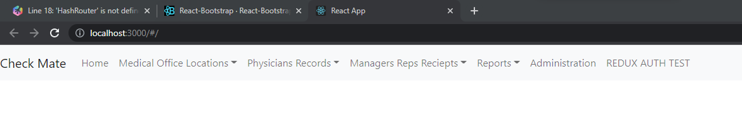  
  
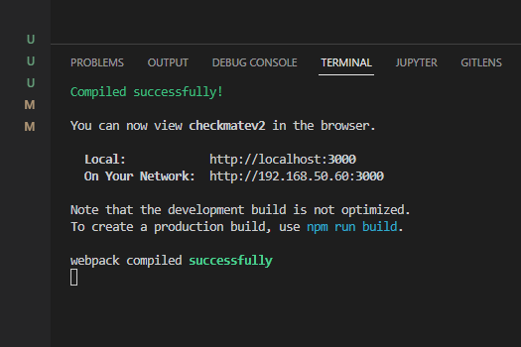  
  
npm i axios  
  
npm i redux-devtools-extension  
  
Install all of this for REDUX  
npm i react-router-dom redux react-redux redux-thunk moment react-moment  
  
And after adding REDUX, it still builds fast  
  
I have the base code:  
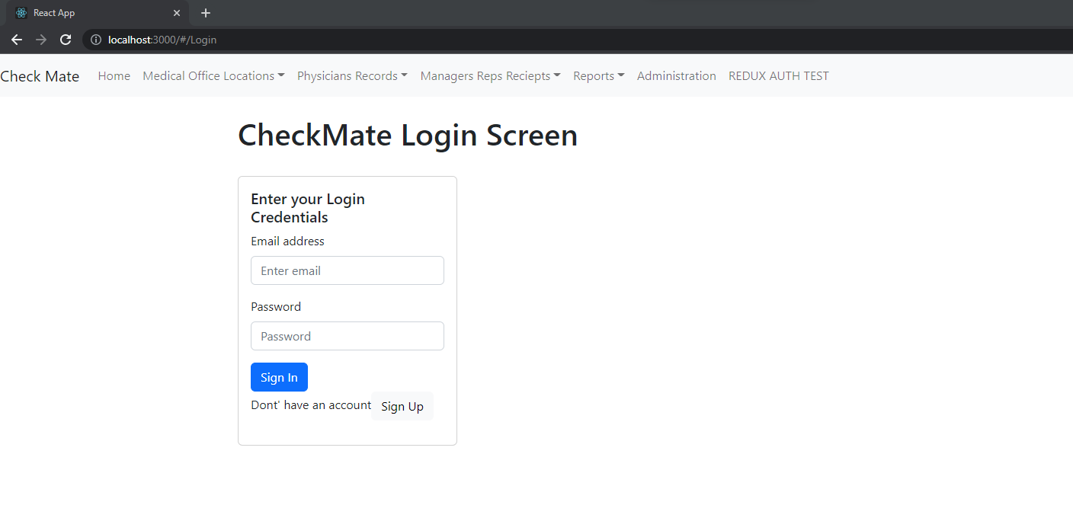  
  
And its lightning fast  
  
To allow for environment variables  
npm i env-cmd  
  
Make sure you put it at the root

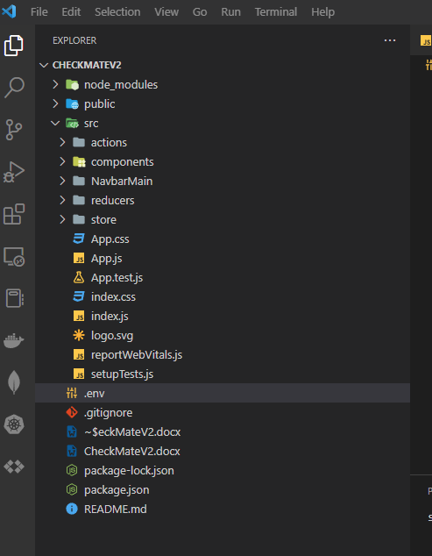  
  
So the login screen and register screen is finished

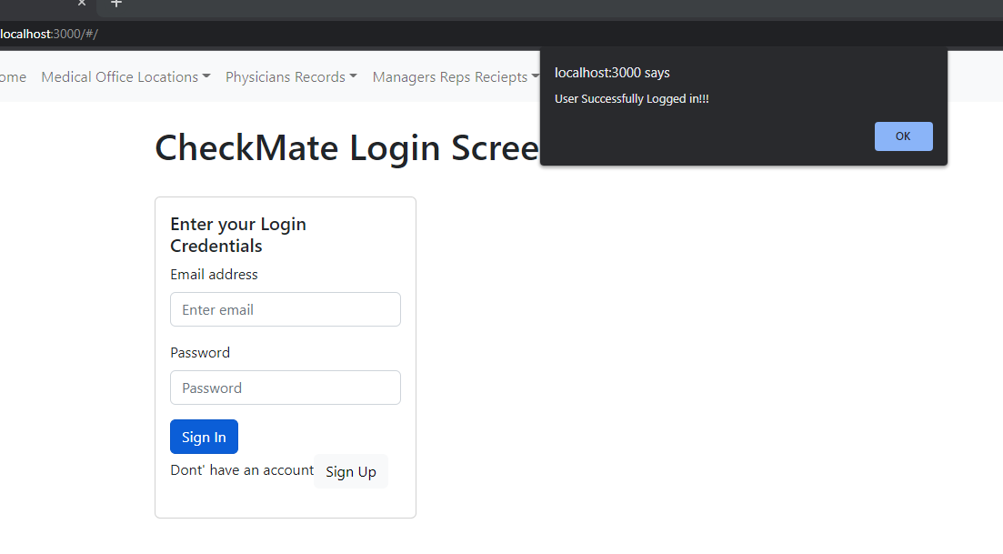  
  
For the bootstrap tables, I had to use the –force with it

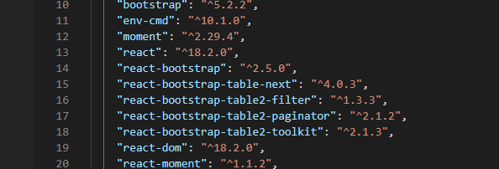  
  
i:e npm install react-bootstrap-table2-toolkit –force  
npm i uuid

**Tip**: Removing options from a select control 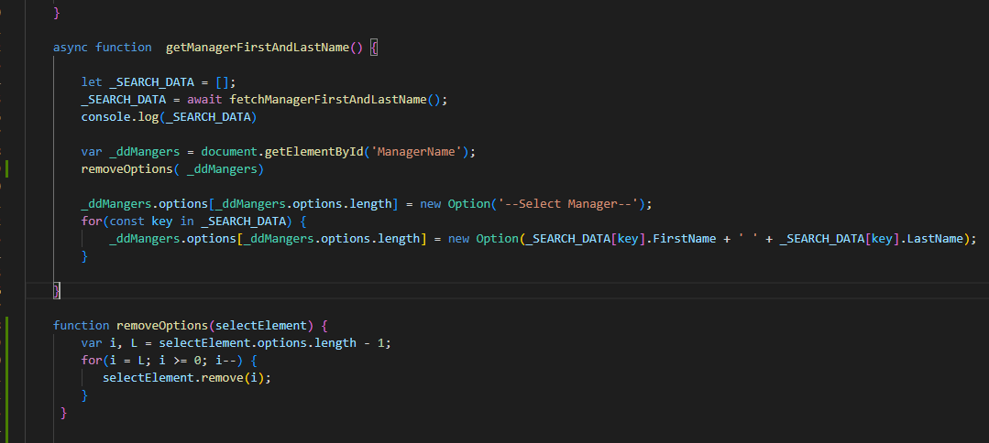

**Tip**: Deploying to Heroku  
These steps are followed from my other two deployments  
  
We modify our first three files as shown below:  
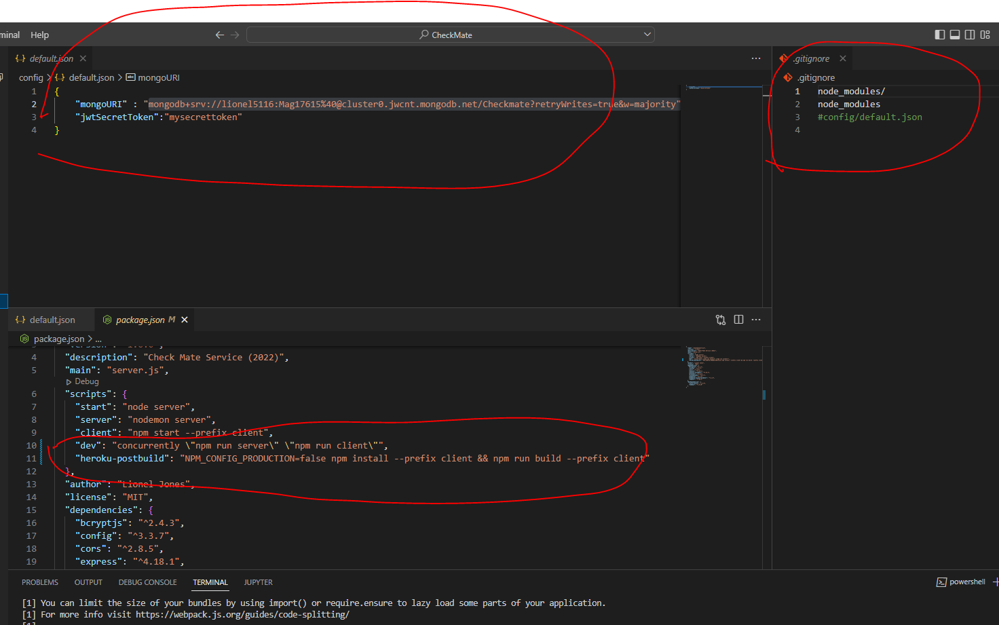  
  
Update (You have to use the –force) in the package.json, or Heroku will error out

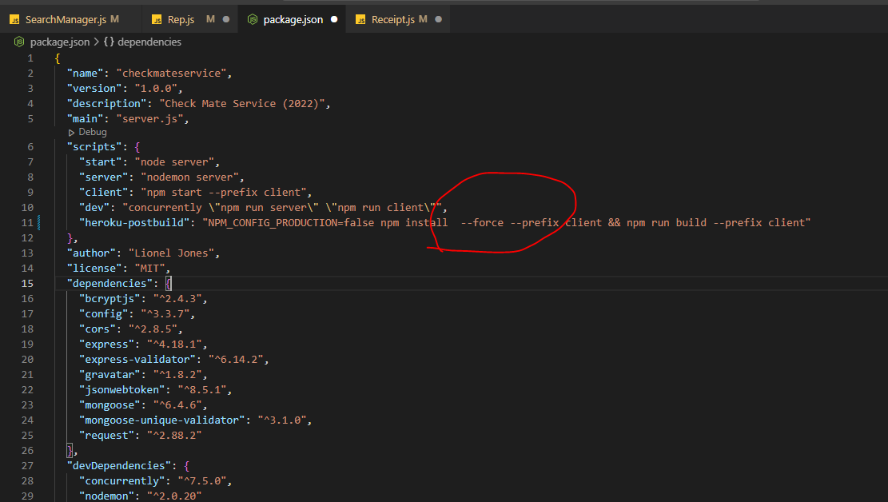

default.json  
.gitignore  
package.json  
  
See your AssetManagemt2022 for the correct content  
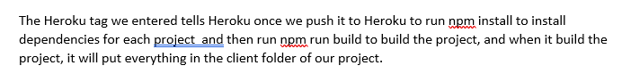  
  
Then in your server.js file:  
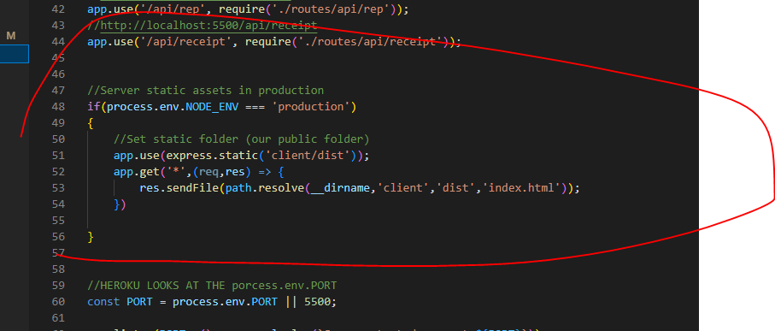  
  
Next at the terminal, do a Heroku login  
Heroku login  
  
Check your version  
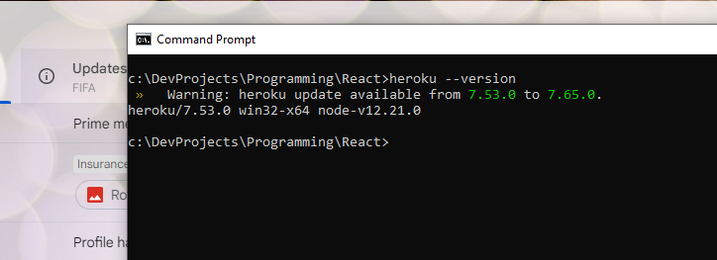

Next create an app  
Heroku create

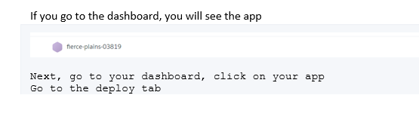

Go to the deploy tab  
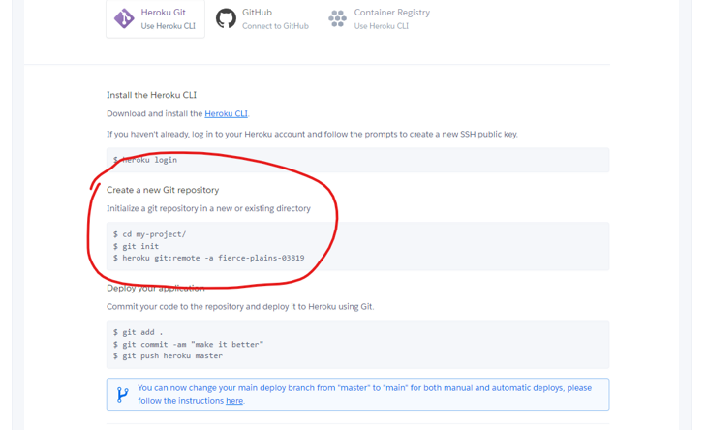  
  
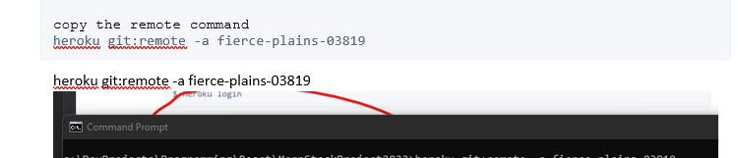

Make sure you in your directory  
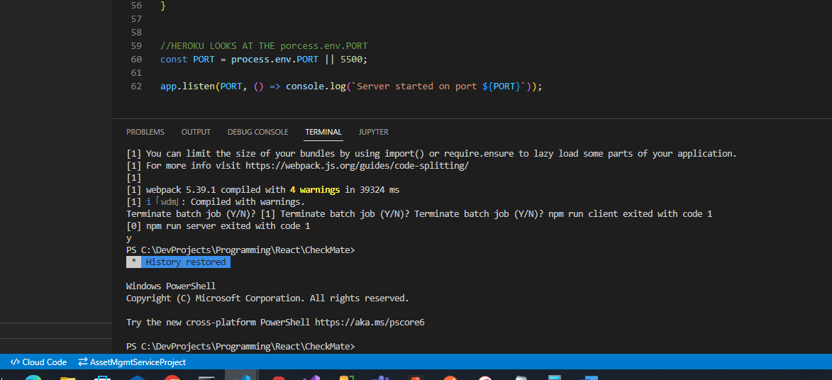  
  
Then type in the line from here:  
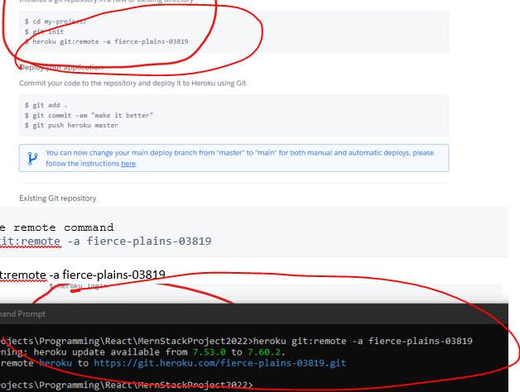  
  
This adds a remote repo for Heroku  
  
**Then do all of your regular commits locally**  
git add -A  
git add .  
git commit -m "first commit"   
git push origin master   
  
**Now push to Heroku**  
  
git push Heroku master  
  
After that, watch the build, it should succeed.  
  
You can go to your Heroku dashboard and view your app and browse it.

**Tip**: Running the app on a mac (when apache is running and webpack is an issue)  
On a mac, if you do a npm install on the client folder, you will get a npm run webpack error,  
If you look at the error, it will tell you what command to run to get npm install to run  
npm install -f (or npm install -force  
  
For Apache – The default port for Apache Is set to 8080  
Stop Apache with:  
brew services stop http  
Then when you run your application, the default page will come up if cached, it that happens , do a page refresh and it will come up

**Tip**: Splitting the Service and deploying to GCP

I split out the service to it’s own folder  
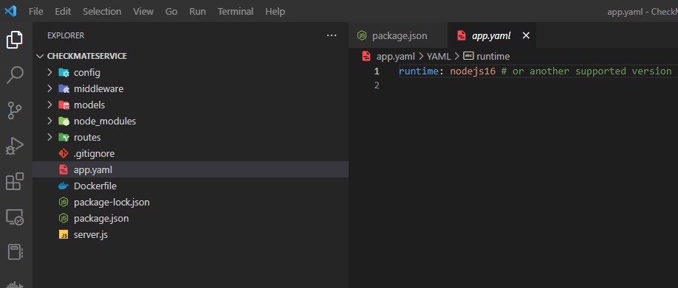  
  
<https://github.com/lionel5116/CheckMateService.git>  
git remote add origin https://github.com/lionel5116/CheckMate.git   
git add -A  
git add .  
git commit -m "first commit"   
git push origin master   
  
I made sure to include the app.yaml fie  
I went to Google Cloud and created a new project

I logged into google cloud and created a new project  
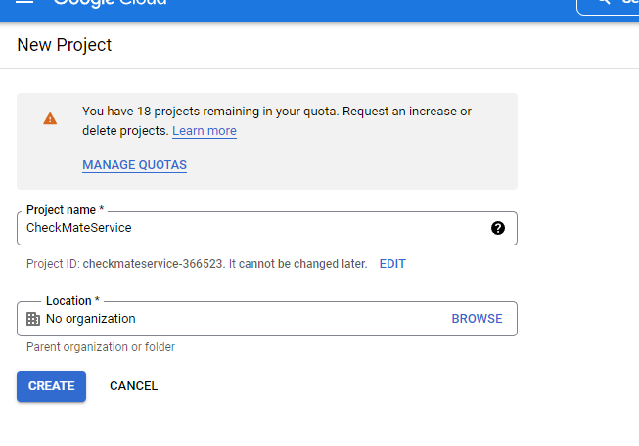  
  
When I finished I was in the new project context of checkmate service  
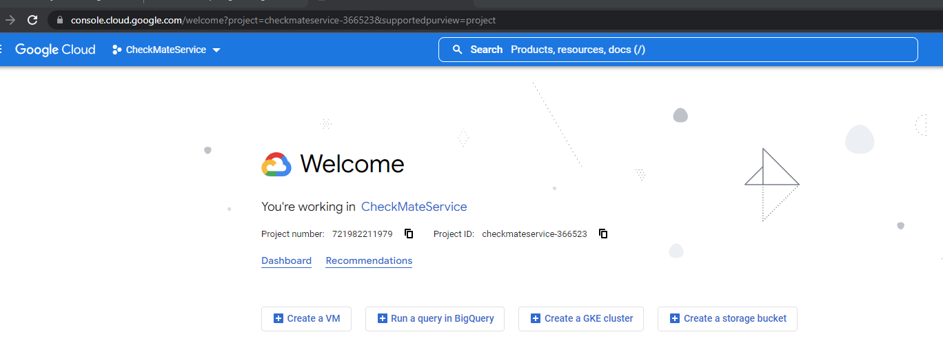  
  
I t hen selected AppEngine from the burger menu at the top right  
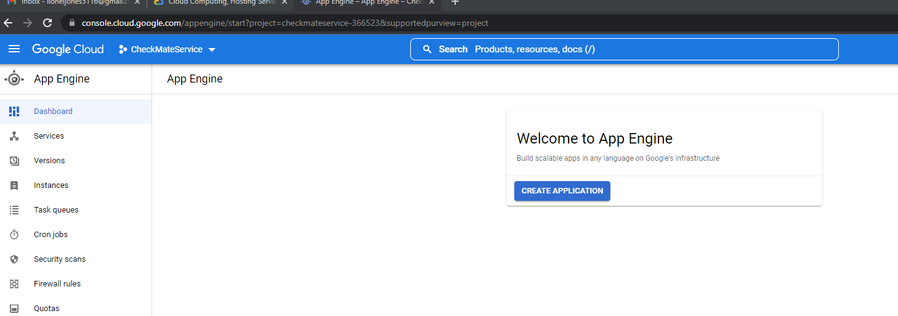  
  
When my app was created, I went to the shell  
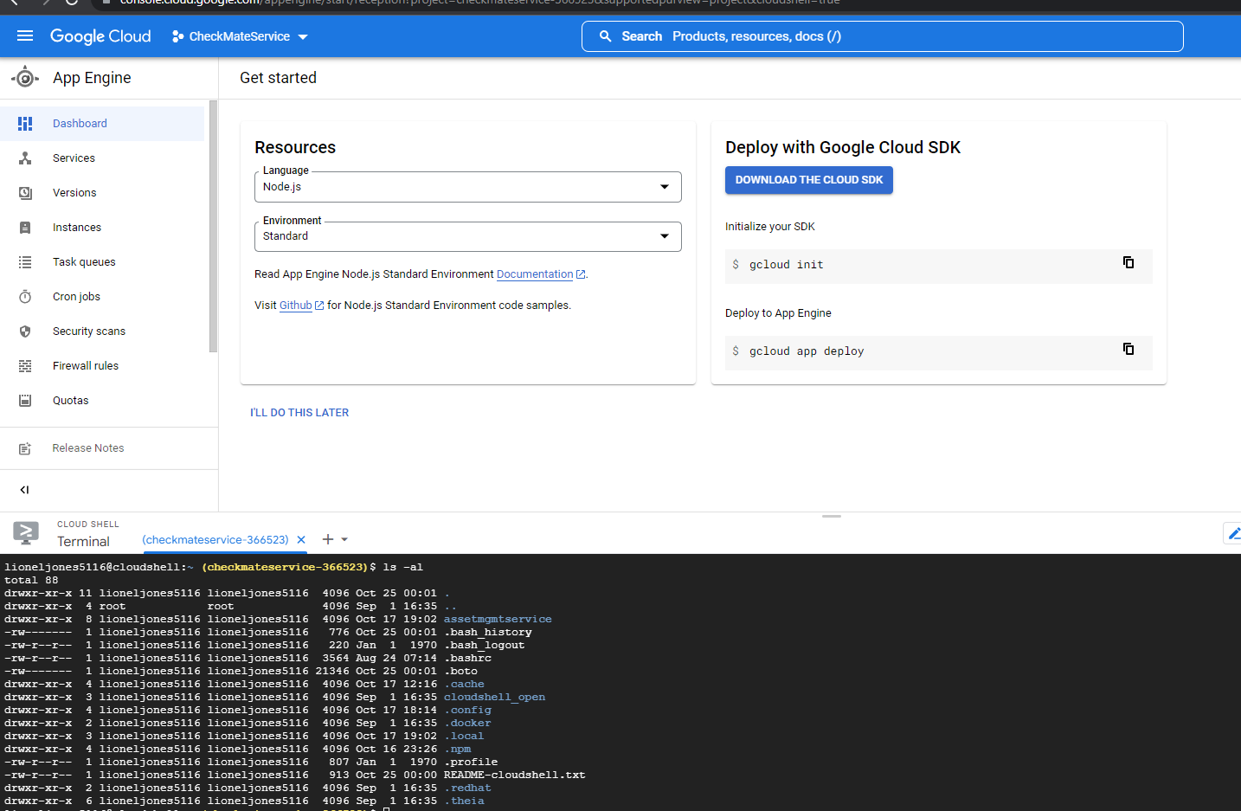  
  
And did a gcloud init  
This made sure that I was in the correct path for the files that I would be pulling down from github. If you notice with this new application, you do not see any of the files from the assetmgmt2022 service. That’s why you have to   
create a new project,   
go to App engine,   
create a new app   
and then re-initialize  
  
Next I am going to clone my repo  
git clone <https://github.com/lionel5116/CheckMateService.git>  
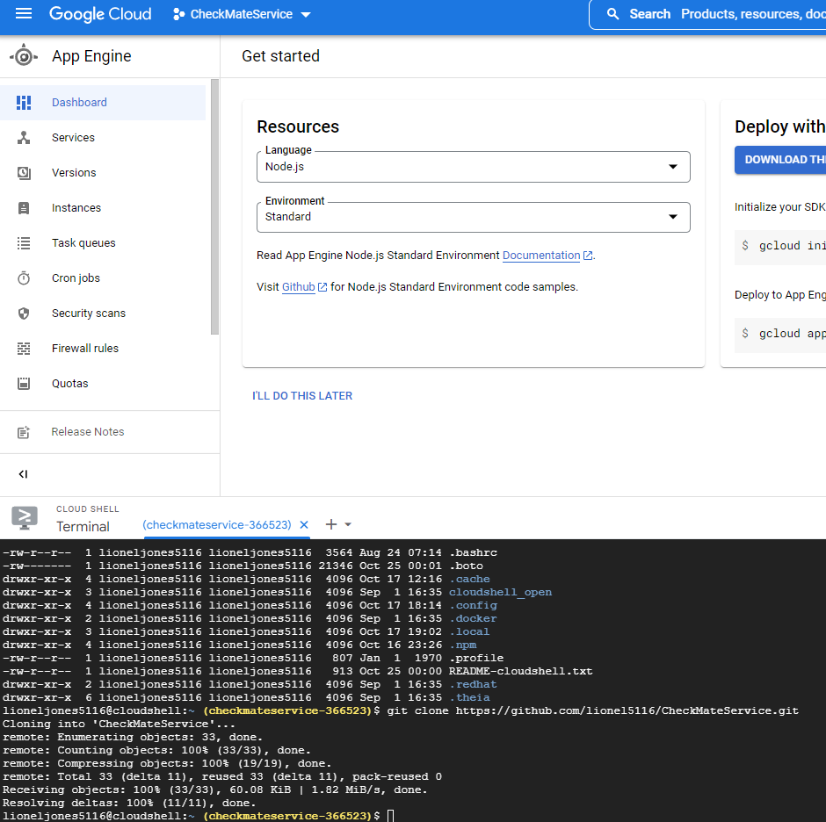  
  
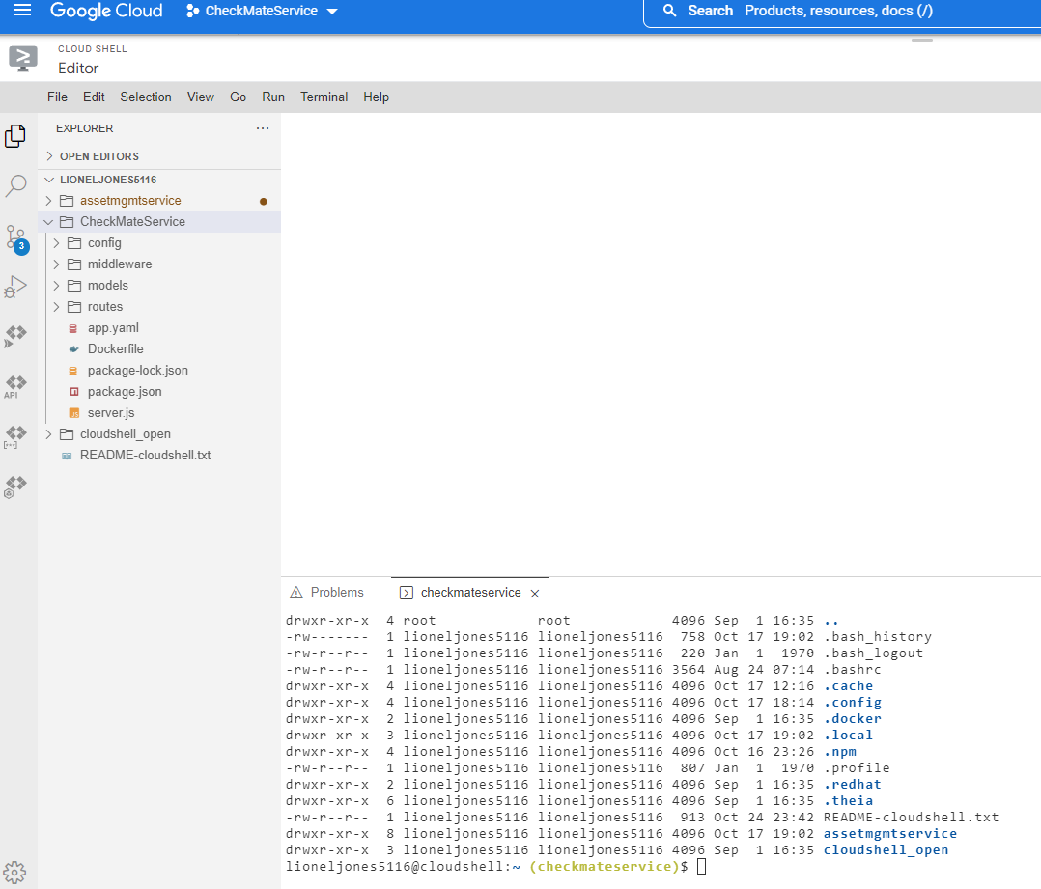  
  
You will see all of your projects (just like VSCODE) – This is VSCode, but you are in the directory of your new service  
cd into your checkmateservice folder

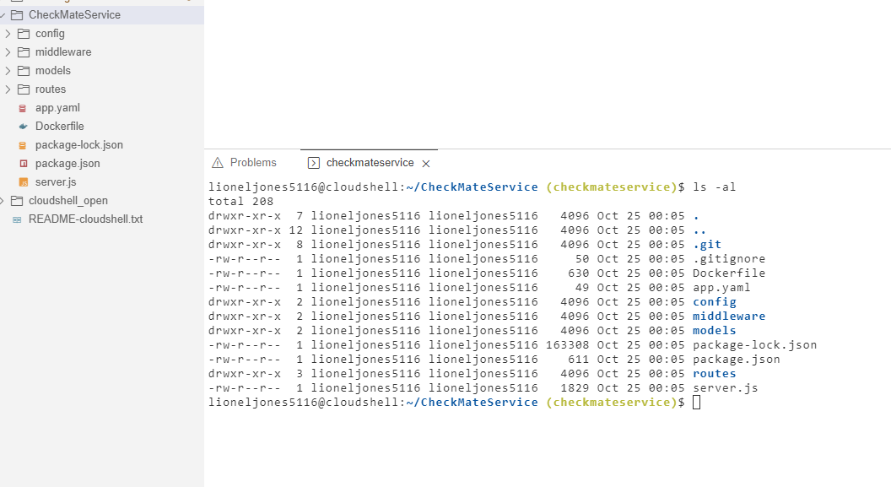  
  
do an npm install to install your modules  
Then do a npm start

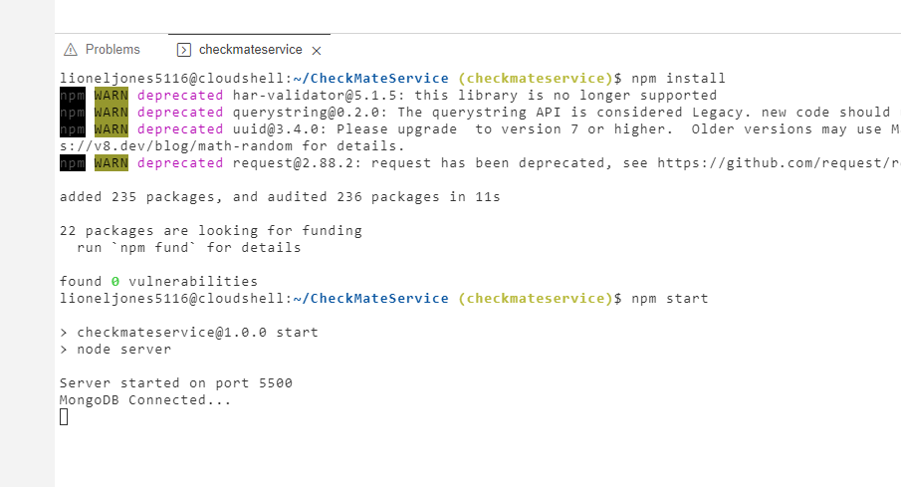  
  
Now deploy  
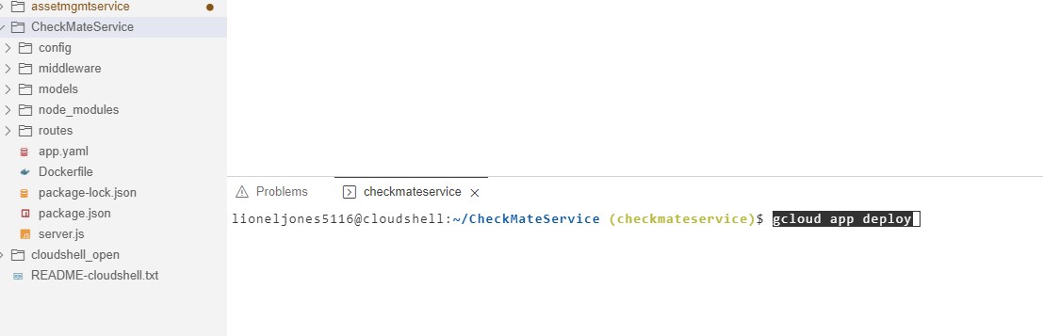  
  
  
I got a permission denied error at first, because it was referencing a project with the wrong project ID. I just went back to the project selector, made sure I was in right context and directory at the shell.  
  
Then I typed this  
  
  
This made sure I was in the correct context  
Then I did a  
gcloud app deploy  
  
I got another error:  
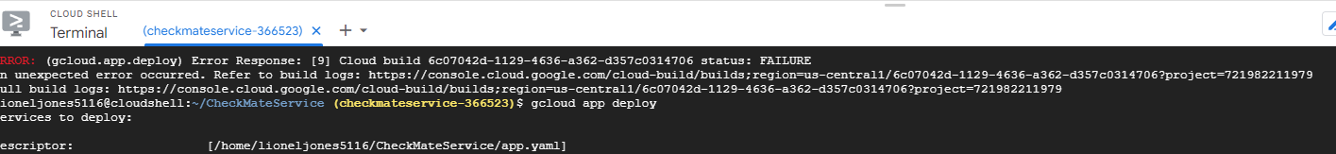  
  
But this was standard error that I always get on first build  
  
After typing deploy again, the build went through  
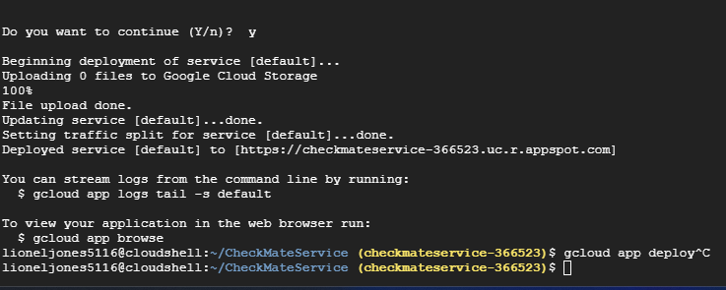  
  
I went to the dashboard  
  
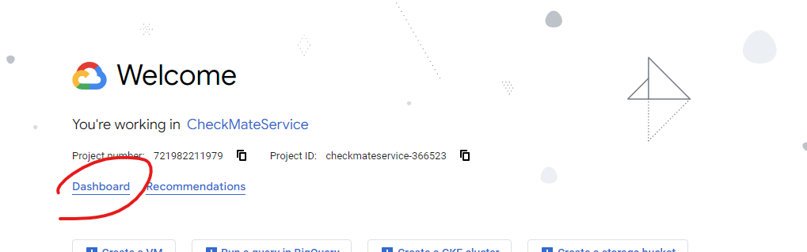  
  
Clicked on App Engine  
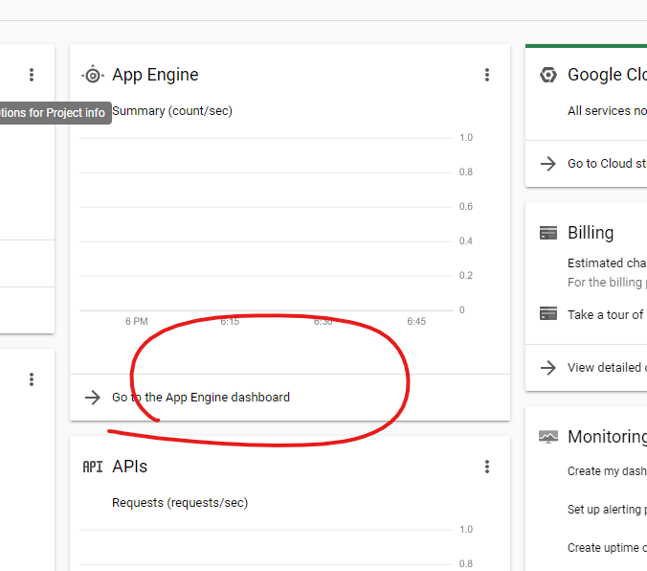  
  
There is your link  
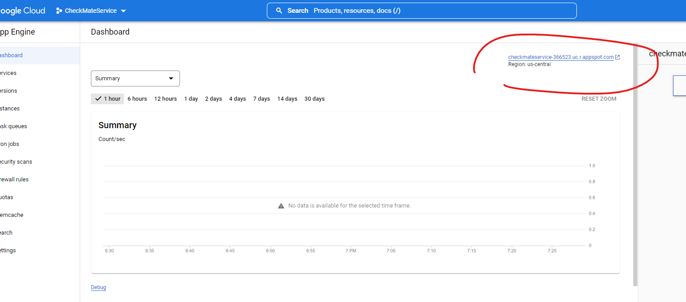  
  
https://checkmateservice-366523.uc.r.appspot.com/  
  
When I browse, it says not found  
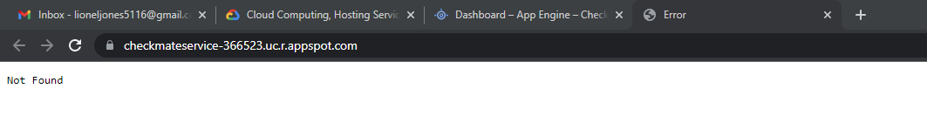  
  
I created another project  
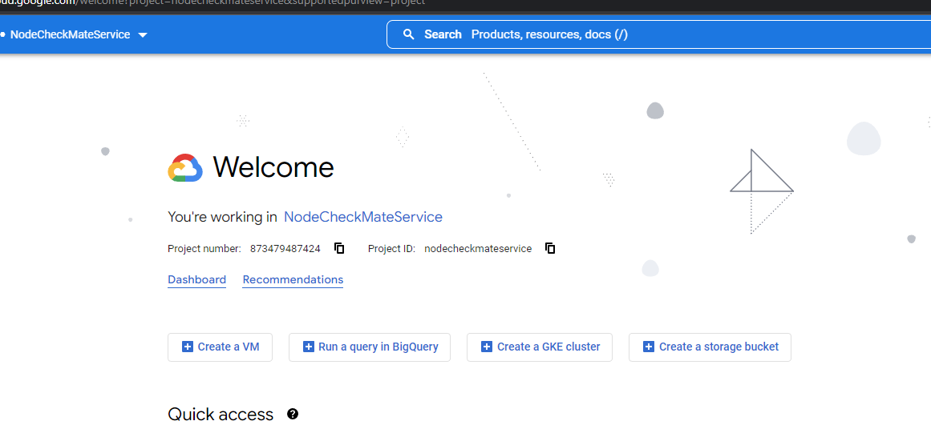  
  
I removed the old folder

rm -rf CheckMateService/  
  
Same process, still 404

**Tip**: How to grab fields from MongoDB and dynamically populate a select

In this scenario, I had to find a way to populate a select dynamically from a record where the values were in two columns (First Name and Last Name). The end result:

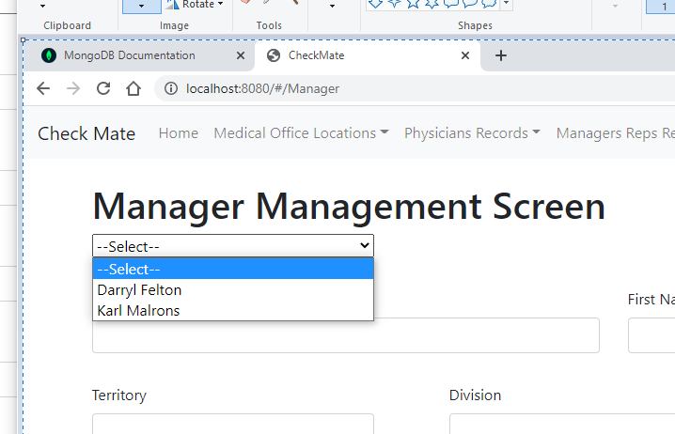  
  
The solution  
I created a custom route:  
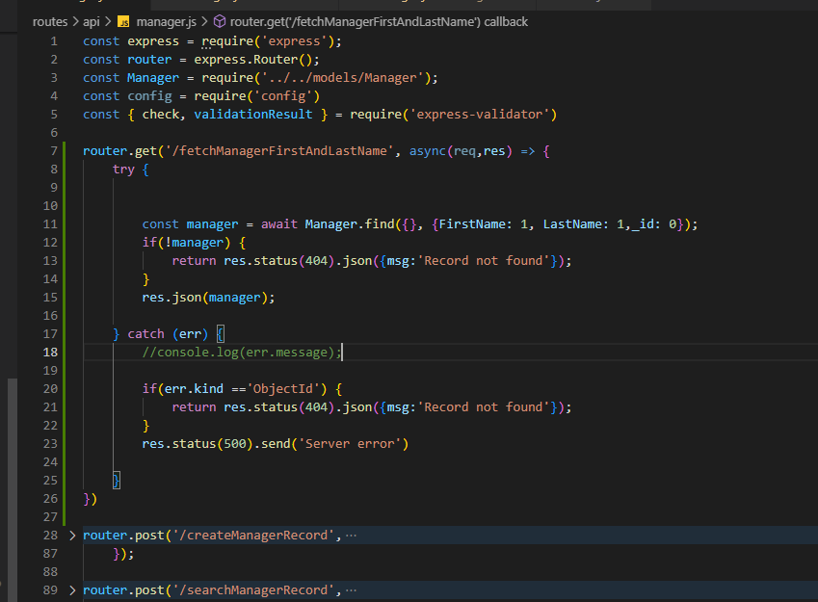  
  
The mongodb syntax returns the columns I needed (FirstName and Last Name)  
Then I created an action

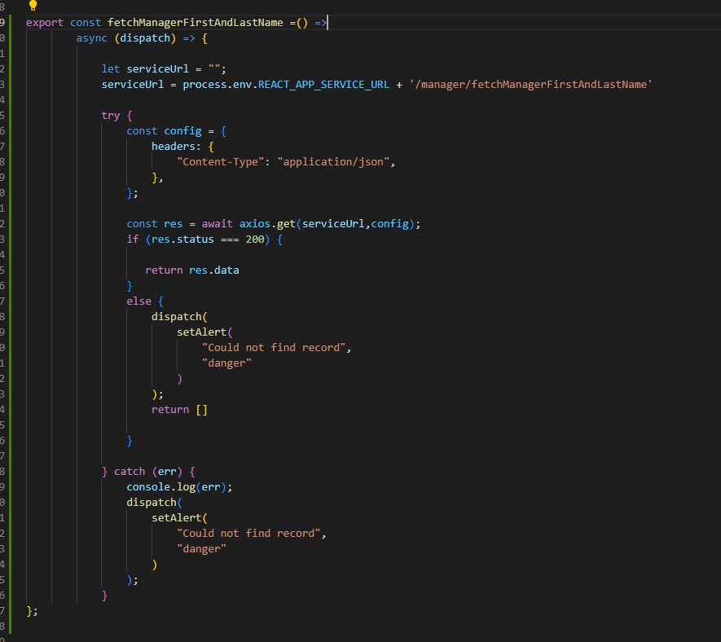  
  
Then I made a call to grab the items and dynamically populate a select control

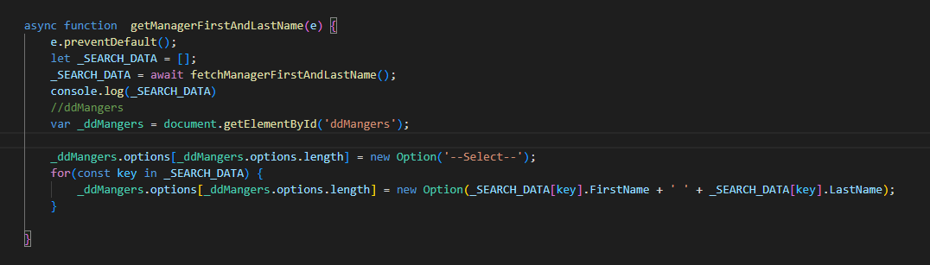  
  
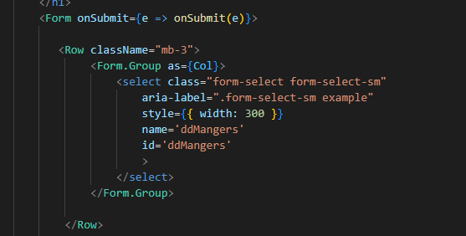

**Tip**: Creating custom routes with express js  
Any custom route you create is done with   
router.get(/<the name of your route..>

So for example:  
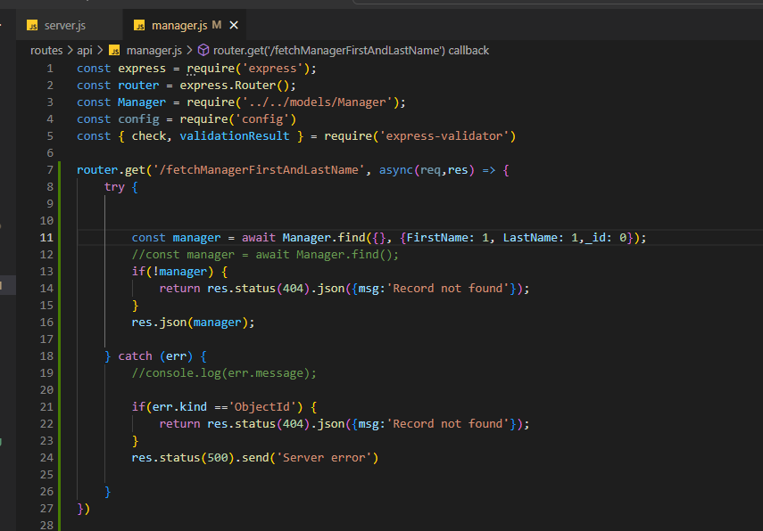  
  
<http://localhost:5500/api/manager/fetchManagerFirstAndLastName>  
  
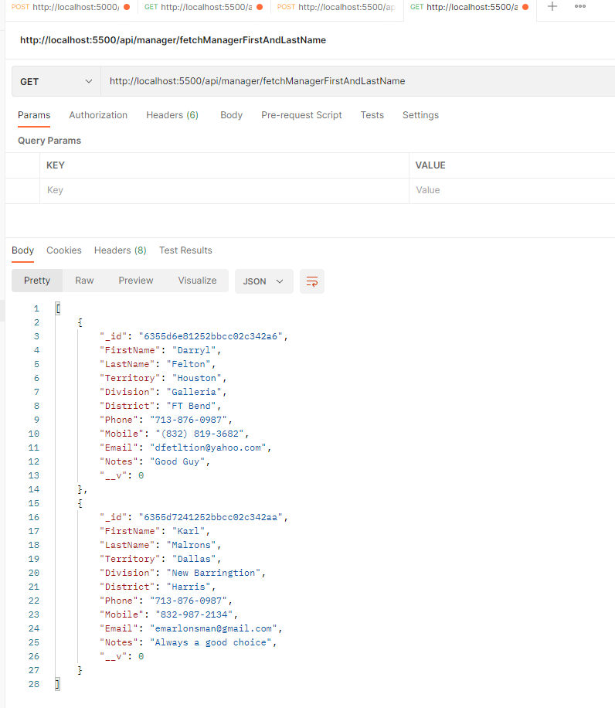  
  
But one important note:  
YOU HAVE TO HAVE ALL OF YOUR CUSTOM ROUTES BEFORE YOUR OTHER REGULAR GET,PUT,DELETE ETC.. ROUTES ARE YOU WILL GET AN ERROR:  
  
  
So your routes have to be in this order  
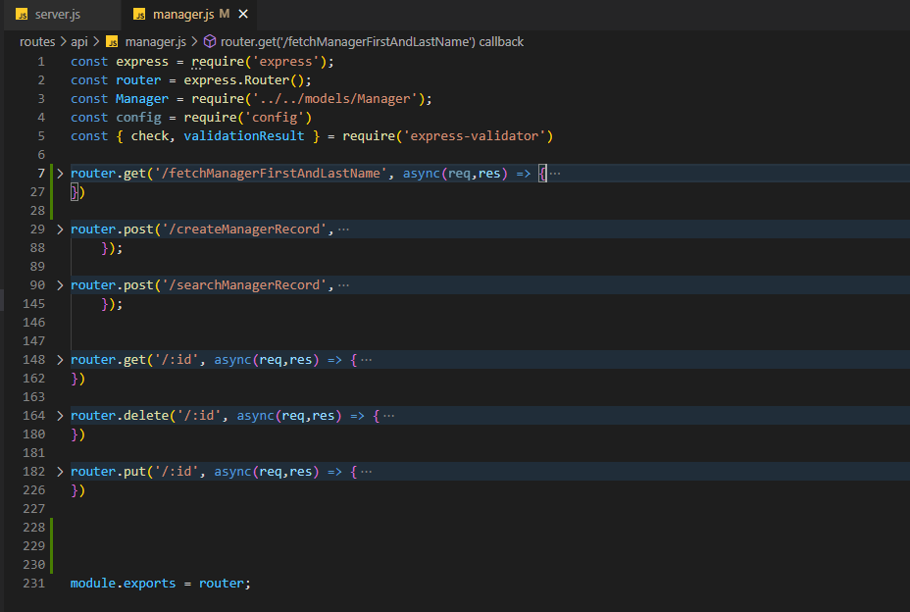

**Tip**: MongoDB Commands – Visual Studio Code  
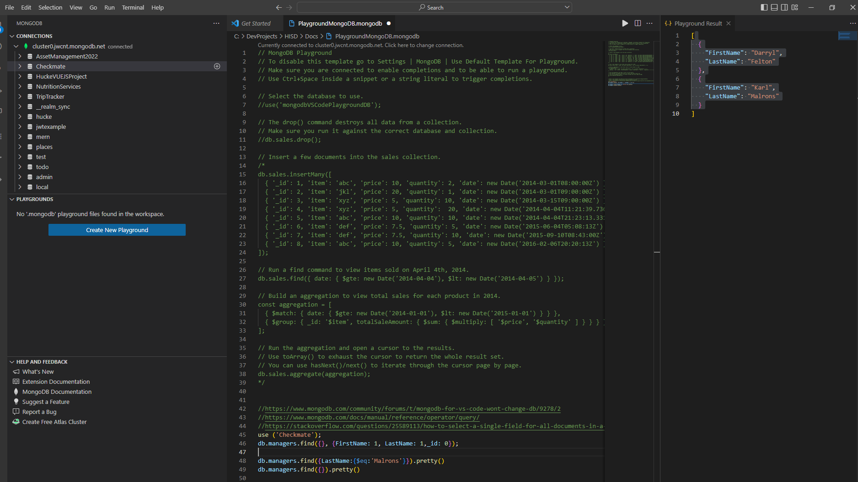  
  
The way playgrounds work is that you have to use the syntax as shown below. (Each run you do you have to specify what database you want to use at each run. The last command always is shown. It does show all lines, just the results from the last line  
  
https://www.mongodb.com/community/forums/t/mongodb-for-vs-code-wont-change-db/9278/2

https://www.mongodb.com/docs/manual/reference/operator/query/

https://stackoverflow.com/questions/25589113/how-to-select-a-single-field-for-all-documents-in-a-mongodb-collection

use ('Checkmate');

**//return specific columns (the _id:0 means do not return the id column)**

db.managers.find({}, {FirstName: 1, LastName: 1,_id: 0});

**//filter the result from managers where the last name = 'Marlons'**

db.managers.find({LastName:{$eq:'Malrons'}}).pretty()

**//show all records in the managers collection**

db.managers.find({}).pretty()

So to run a command, highlight the syntax and hit the run button

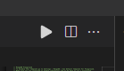

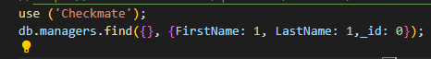

**Results:**

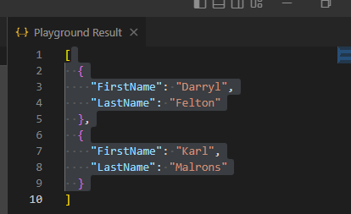

This is a custom route that returns first and last name from the managers model

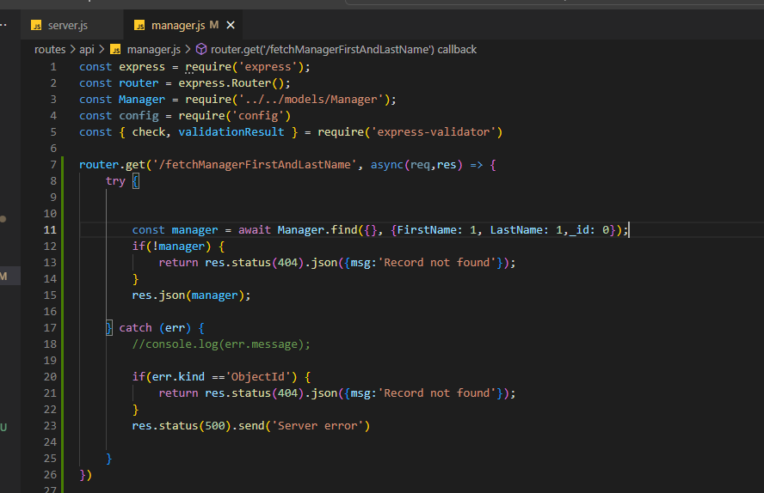

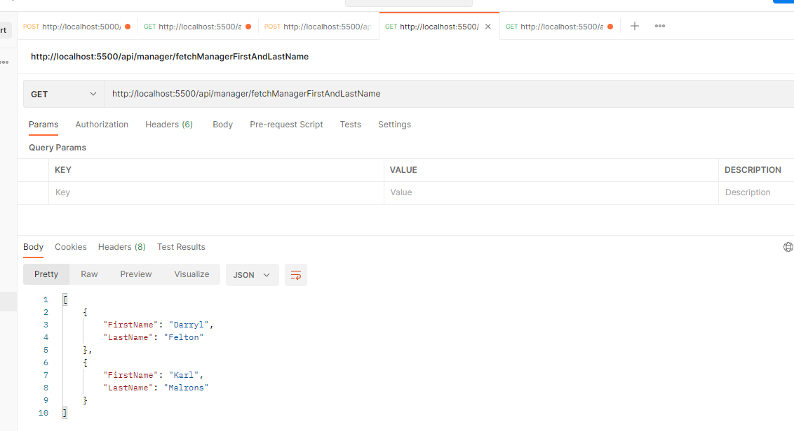  
  
It’s the same syntax as what I used in playgrounds  
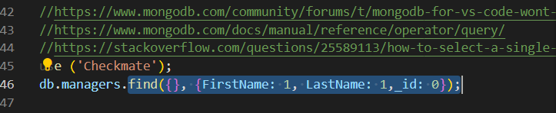

So the **MongoDB Syntax works !!!,** We are just using Mongoose objects, you just replace the db.managers. with   
Manager.

**Tip**: Check for open port  
netstat -aon

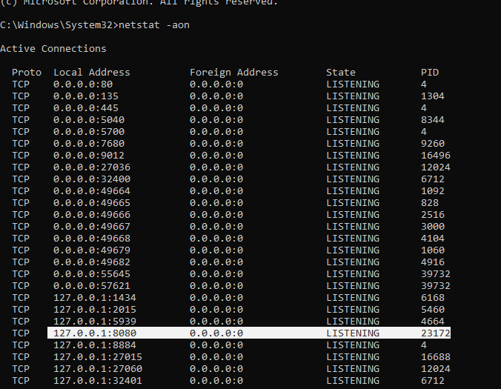For individual Port  
netstat -ano | findstr :8080

**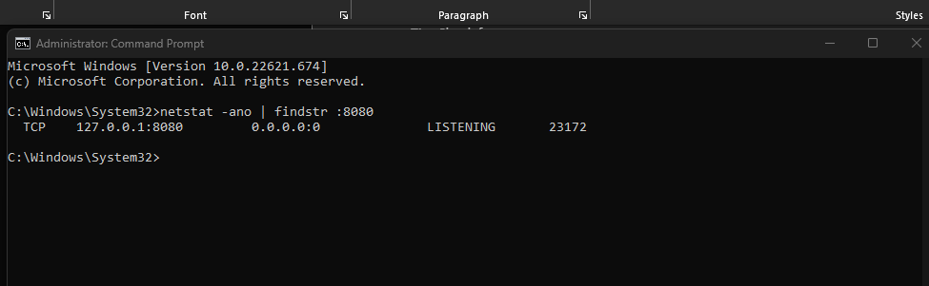  
  
to kill**

**taskkill /PID 23172 /F**

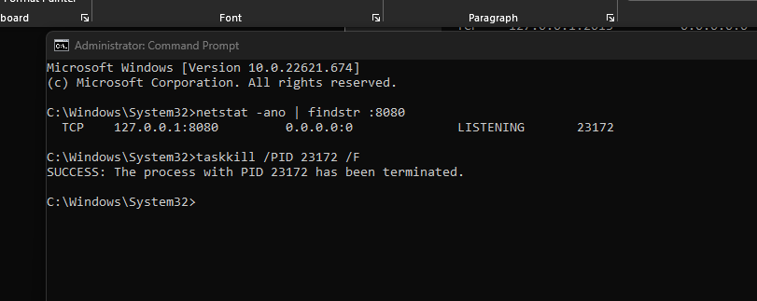

**Tip**: Fixing the issue when you fetch for record to edit and then type in a field and all of you data disappears from other fields

When you bring back a record, you have to set the field values like this

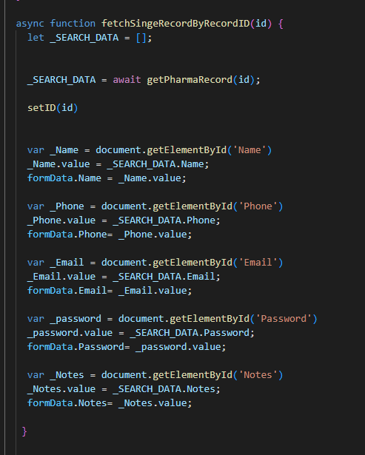

If not, when you type in one field, it will wipe out your model  
I don’t need the code below, I am just keeping it for reference

  /*

  function onChange (e){

    e.preventDefault();

    const { name, value } = e.target;

    switch (name) {

        case 'Name':

          setFormData({ ...formData, Name: value });

            break;

        case 'Phone':

          setFormData({ ...formData, Phone: value });

            break;

        case 'Email':

          setFormData({ ...formData, Email: value });

            break;

        case 'Password':

          setFormData({ ...formData, Password: value });

            break;

        case 'Notes':

          setFormData({ ...formData, Notes: value });

            break;

        default:

            break;

    }

   // console.log(user)

  }

  */

**Tip: Starting development  
Git repo**[**https://github.com/lionel5116/CheckMate.git**](https://github.com/lionel5116/CheckMate.git)

**Project breakdown  
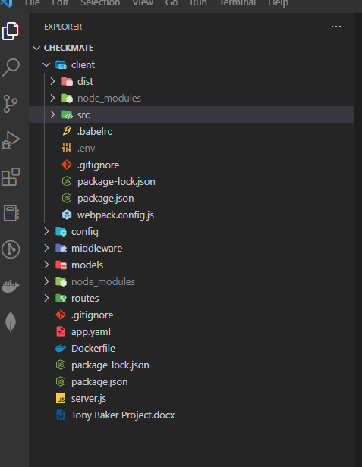  
  
Combined directory with  
React Client App  
NodeJs Service  
  
I have authentication working**

**SCREENS**

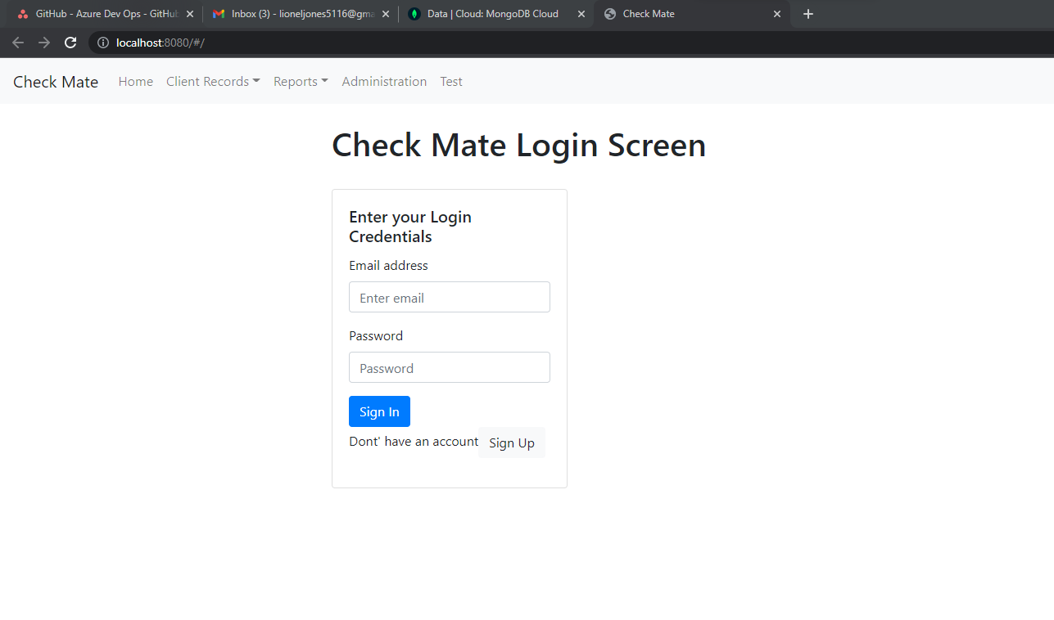

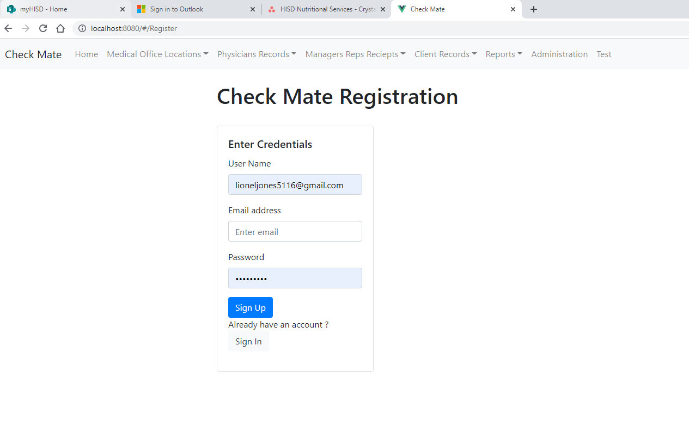

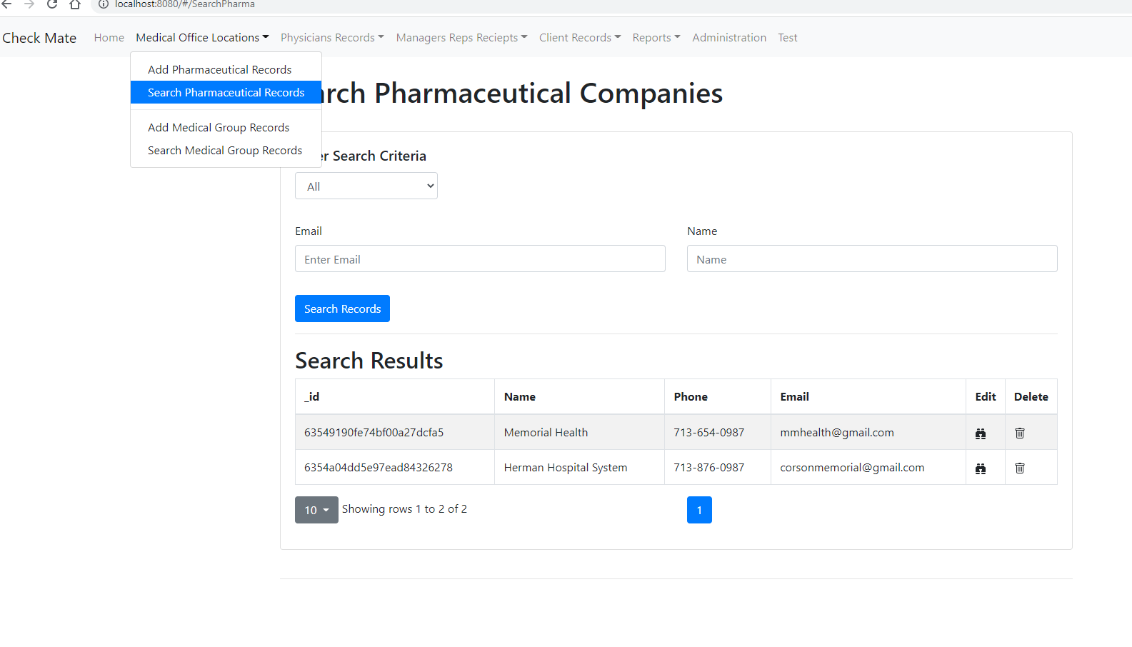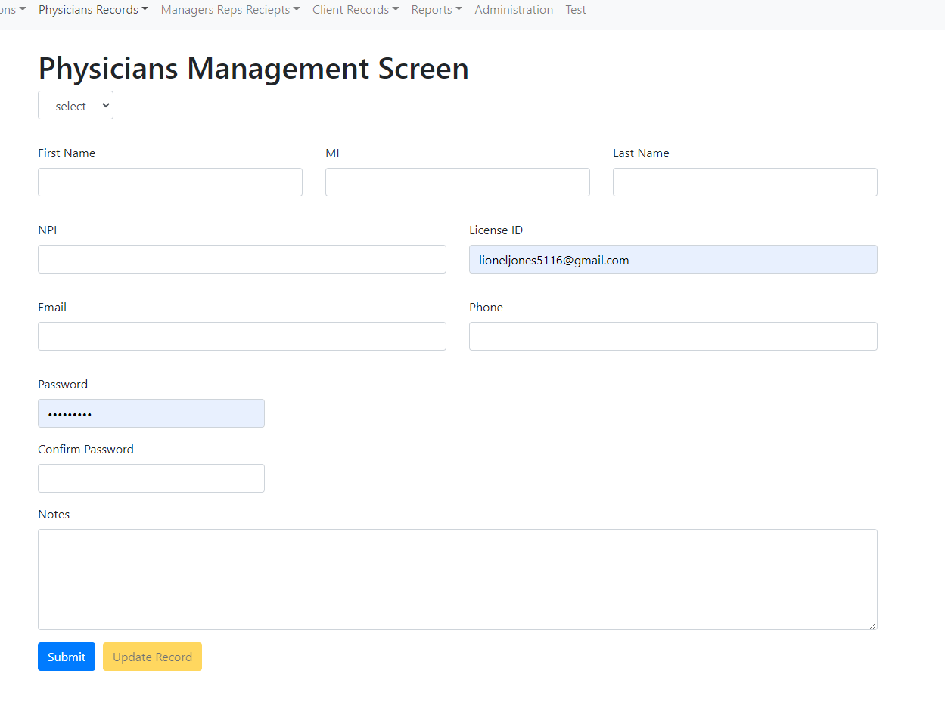

**The Rep Screen**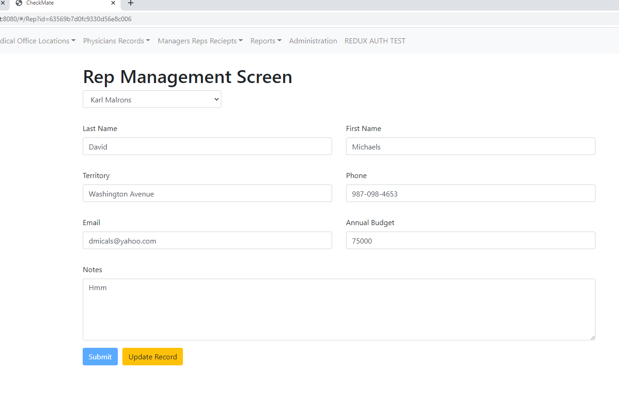The drop-down is from the Managers table – **Every Rep is associated with a Manager**

On the Search Rep Screen, you can find all reps that are associated with a Manager

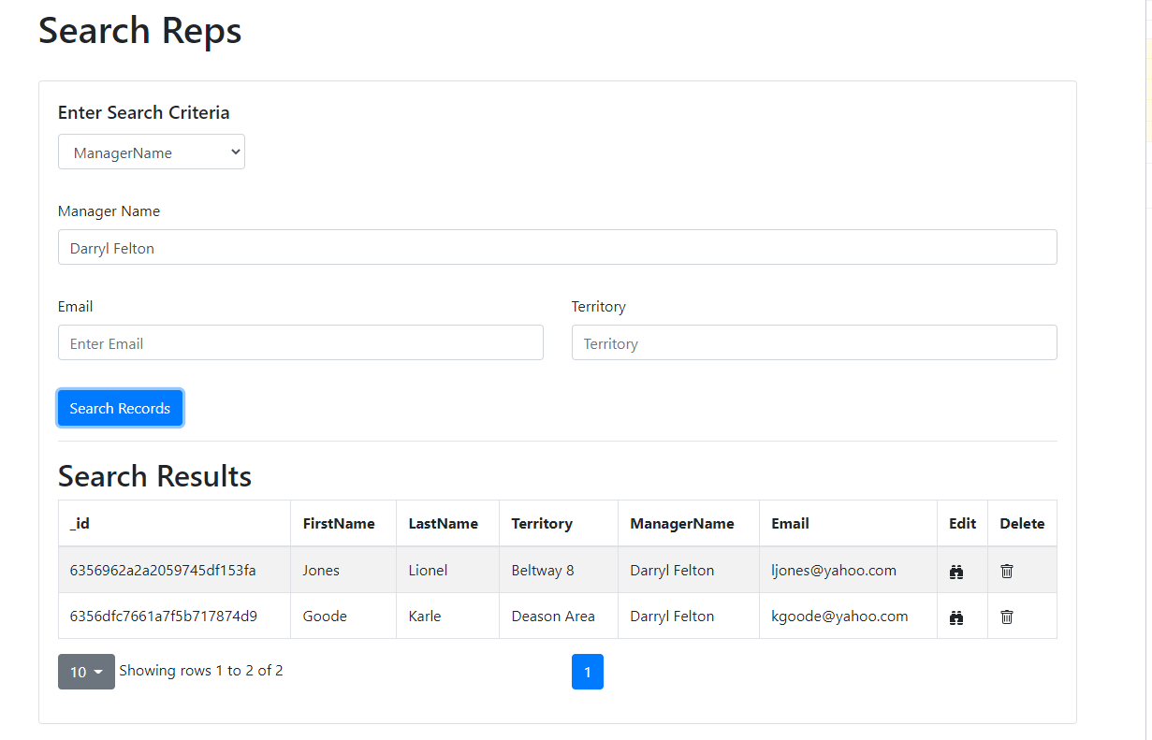

**Document Start Date:**  
October 20, 2022

**Purpose of the application:**  
This application is responsible for tracking and compliance with Pharmaceutical expenses that reps incur while negotiating a drug with doctors  
  
**Use Case(s)- Needs**  
The application needs to a SAS (Software as a Service Application)  
In needs to be a subscription based model application.

**User Count(s)**  
The future number of users can exceed 10,000+ (once the business get’s going)  
  
**Scalability**  
The application has to be designed to scale  
  
**Future Enhancement (Requests)**  
Client wants the ability for the application to integrate with third party products (i:e SAP)  
  
**Software Architecture**  
The application needs to be a multi-tier application  
Front End (Either React or VueJS)  
Middle Tier: NodeJS or .Net  
Database: SQL Server or MongoDB

Payment Processing – Stripe  
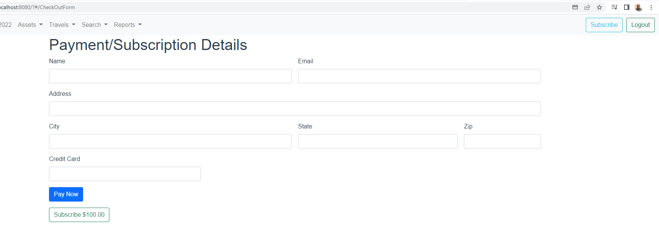  
  
  
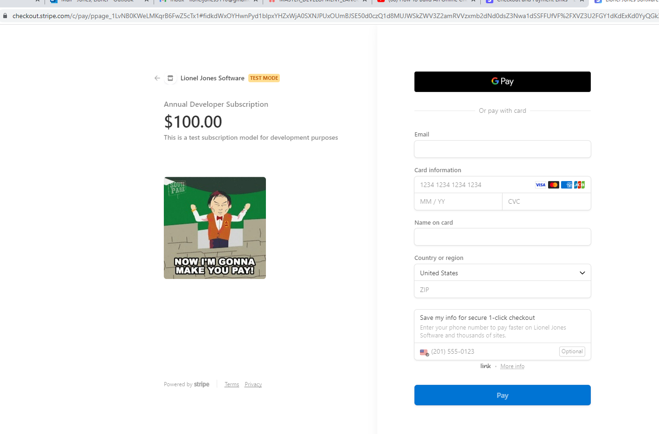  
  
  
  
  
**Key Features:**  
It already has JWT authentication wired up  
It has NodeJS Service that fully configured  
VueJS is easy to code in  
The project is set up to split into multiple parts (you split the client project from the nodejs api) and deploy them separately or together.  
It's a good stack (MEVN)  
**Rapid development time**  
  
  
**Suggestions for UI**/**UX**  
For the UX design, I would suggest getting a good UX design person  
I would have them use FIGMA  
  
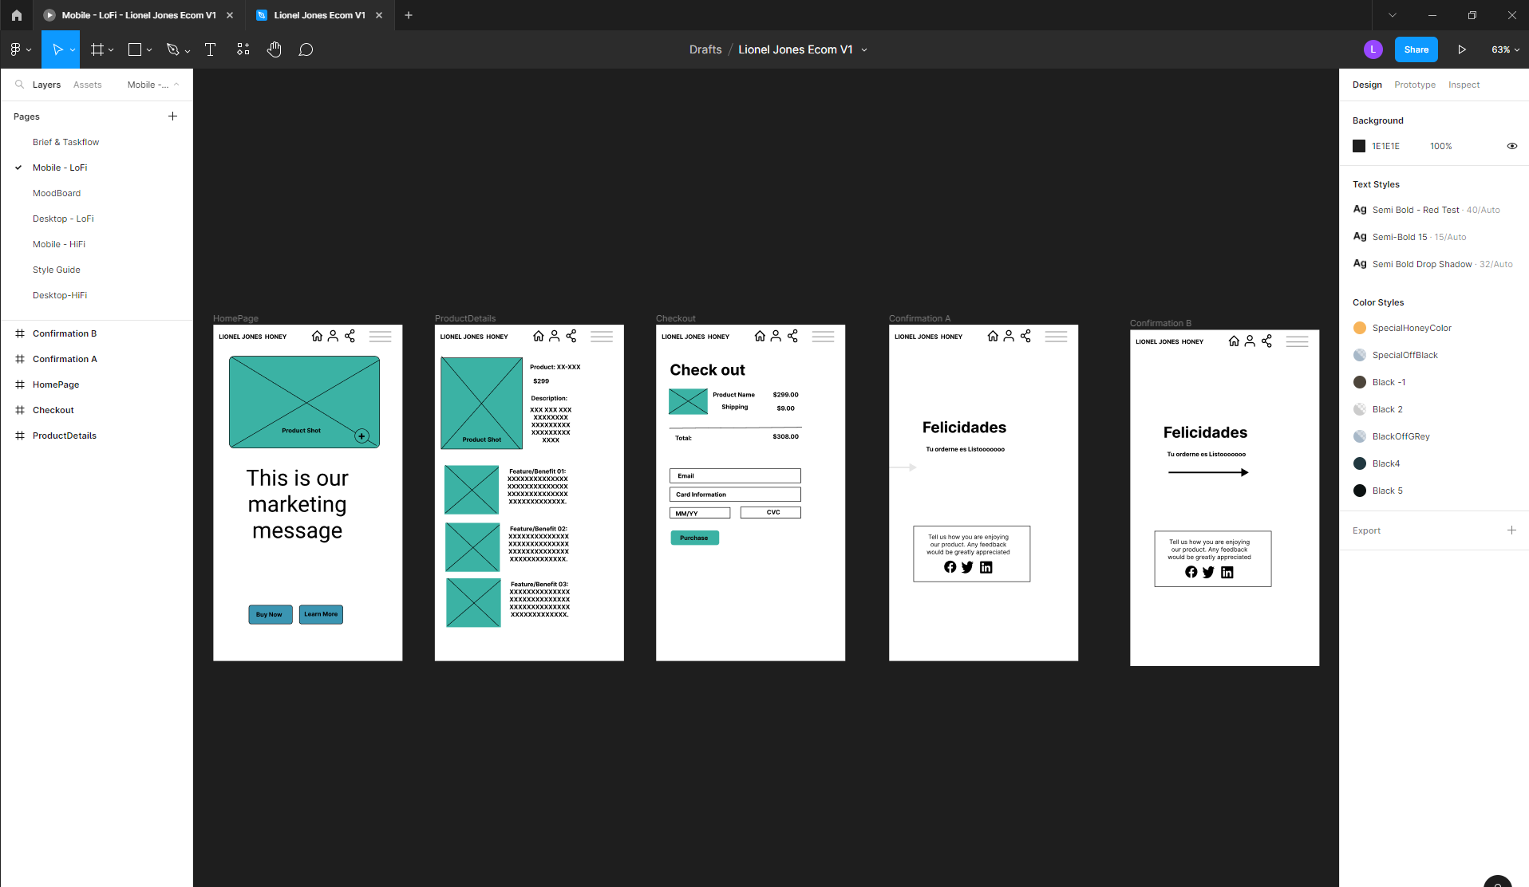  
  
Then turn over the design to the developers for cleanup toward the middle->end of development after the functionality – MVP (Minimal Viable Product) has been developed.  
  
**Hosting  
  
Heroku**  
For low cost hosting (Say for MEVN) stack  
I would go with Heroku  
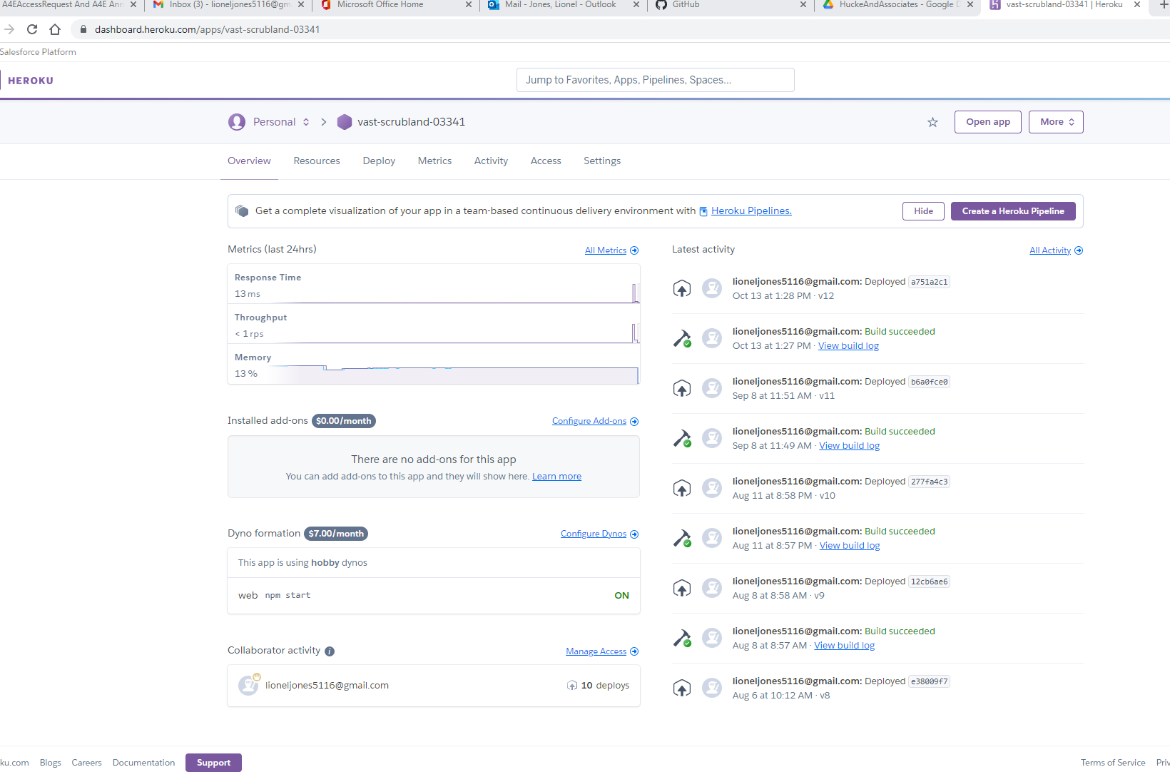  
  
It is an easy process in terms of deployment, cost etc. (This has been proven).  
  
POC – MVP  
If you wanted to put together a quick MVP for proof of concept, a good VUE = MEVN stack project would be good.  
  
**Azure**  
Azure is a good choice. Especially if we go with the React/SQL Based project. It’s Microsoft so porting the Database backend would be seamless. – **Azure is a bit more costly,** but since the application is expected to scale rapidly, this would be a good choice.  
  
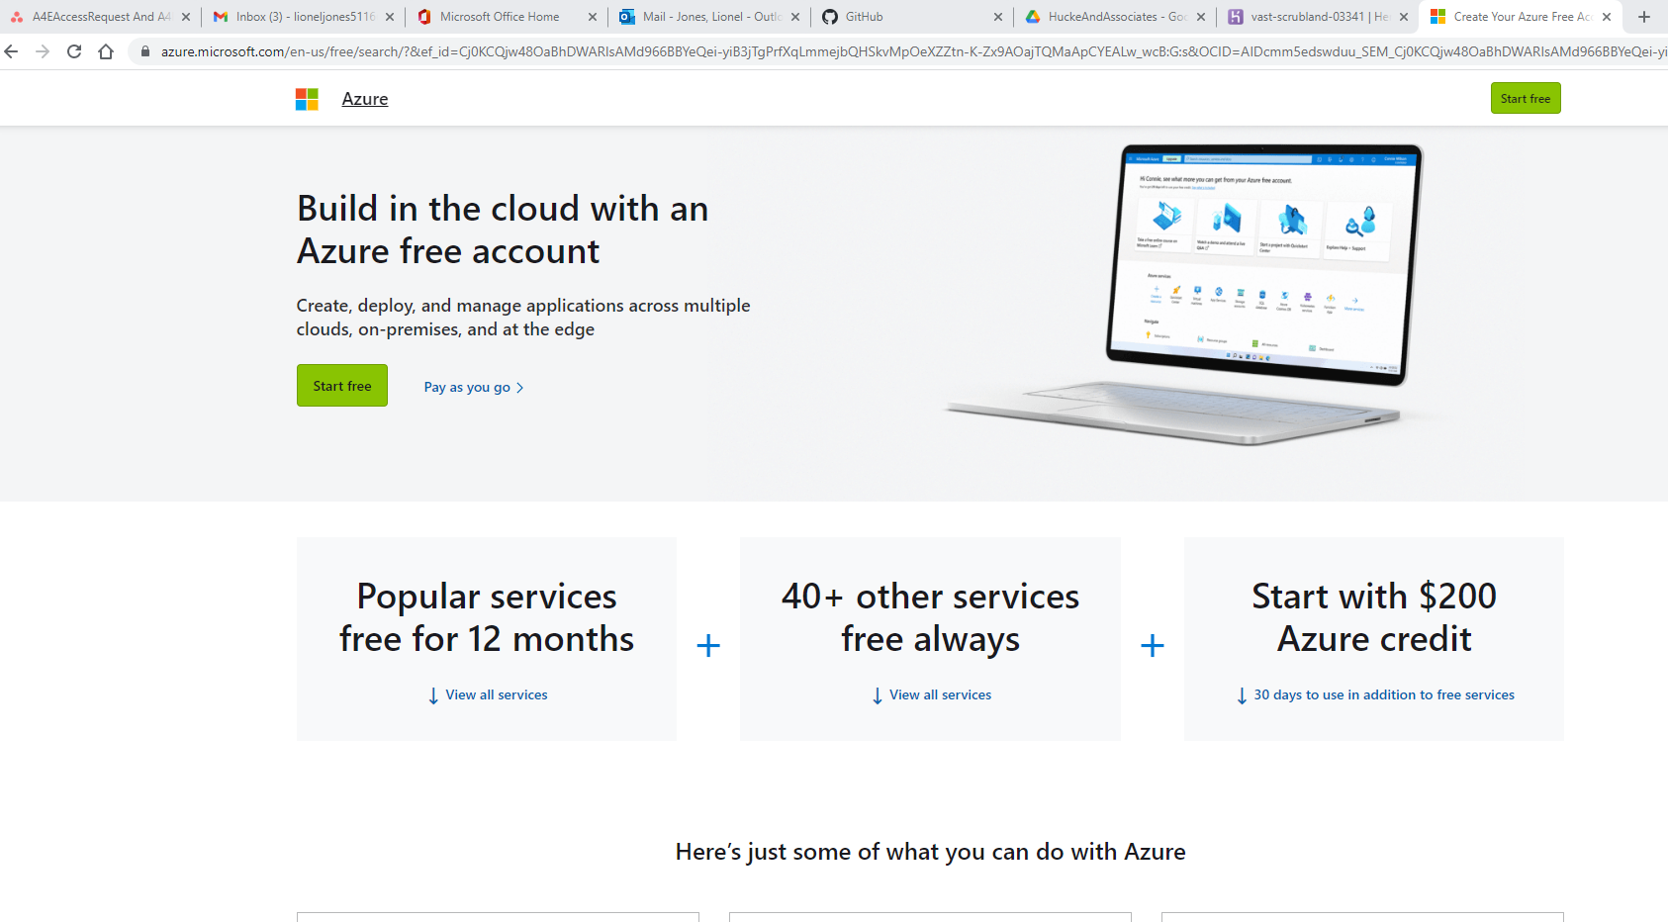  
  
  
  
  
**Final thoughts/Suggestions**Since I can’t find any developers that have the bandwidth  
If I start the project with all of the preliminary design/coding. You could get another group of developers to take the existing code and finish the project. It would be designed well enough for someone to take it over. Just would have to find a good React or VueJS developer (they are fairly common).  
  
I would be willing to:  
  
**For a React/.NET/SQL** based project  
Start the project:  
Deliverables:  
The web service  
Database Design  
The majority of the screens with CRUD (Create, Read, Update, Delete) records  
A search screen with results, Export out the results to excel for reporting  
Payment Processing Screen  
**Total Estimated Hours**: **80** @ 100.00 per hour **$8,000.00 (50% down to start), 50% at time of deliverable  
Advantage(s):**React, SQL Server, .NET – a good scalable stack that any front-end developer (with .net) skills could pick up and finish.   
**The up front cost is cheap for what you are getting**

**For a MEVN** based project (**More of a MVP that could scale**) depending on preference  
Start the project:  
Deliverables:  
The web service  
Database Design  
The majority of the screens with CRUD (Create, Read, Update, Delete) records  
A search screen with results  
Payment Processing Screen  
  
**Total Estimated Hours**: **80** @ 100.00 per hour **$8,000.00 (50% down to start), 50% at time of deliverable  
Advantage(s):**It's a good tech stack (VueJS is easier to code in)  
**Cheaper to Host and get something up pretty quick for an MVP**  
**The up front cost is cheap for what you are getting**  
**Work that would be left**  
**Authentication**:   
(This can already be done with the preliminary coded project – The project that I would develop)  
If you went with the MEVN stack – Heroku (JWT Authentication is already wired up). We would just have to change to fit specific for the business.  
  
If React, the authentication can be written in a different way (Even for JWT above).  
  
Charting/Metrics  
U/X Design (Getting the UI cleaned up)  
  
Estimated cost left to finish (Rough), Depending on who you go with  
Anywhere between **$20,000 - $30,000** +-). You get bids to save $$$  
  
Good Sites to shop for developers:  
<https://www.upwork.com/>  
<https://www.toptal.com/>

**Current App Screen Design – DONE***  
Pharma Table/Screen:  
Create the profile for the Pharma Company  
Fields:  
Name  
Phone  
Email  
Password  
Confirm Password  
  
Medical Group Screen (i:e Herman , Methodist) – DONE***  
Name  
Address  
Office  
Mobile  
Email  
Password  
Confirm Password**

**Physicians – DONE***  
Title  
First Name  
M.I  
Last Name  
NPI  
License ID  
Doctor Email  
Password  
Confirm Password**

**Manager Screen – DONE*  
First  
Last  
Territory Code/Name  
Division  
District  
Phone  
Mobile   
Email**

**Rep Profile = DONE – DONE **  
Manager Name (Dropdown)  
First Name  
Last Name  
Territory Name/ Number  
Phone  
Email  
Annual Budget**

**Receipts Screen– DONE **  
Rep Dropdown  
Restaurant  
Amount  
Shared Amount  
Date   
Event  
Doctors  
Notes  
Upload Image**